Evaluating Common Hands-free Modalities in Supporting Seamless Cross-reality Multitasking

Introduction
Virtual reality (VR) technologies and devices have being rapidly evolved, enabling increasingly immersive and demanding interactions, such as remote meeting and collaboration (Grønbæk et al., 2023), skill training (Bödding et al., 2025), tele-operation (e.g., robots (Alonso et al., 2022), vehicles (El Marai et al., 2023), unmanned aerial vehicles (UAV)(Luo et al., 2022; Widiyanti et al., 2024), aircraft (Verkennis et al., 2025)), systems monitoring and operating (e.g., financial trading (Bonelli & Hamelin, 2022)) and playing immeseive games (e.g., multiplayer first-person shooters (VlahovicSara et al., 2024), racing (Cao et al., 2020)). These experiences are often real-time, fast-paced and non-pausing, requiring continuous manual input that occupies the user’s hands and hinders performing important or time-sensitive real-world (RW) actions in parallel which also require hands, such as using mobile phones, using tools, turning off alarms, attending to children, and operating appliances (Sun & Schöning, 2025). As such, there is a pressing need for adaptively switching interaction modalities that facilitate seamless cross-reality multitasking, allowing users to address real-world demands beyond their ongoing virtual experiences.
One promising approach to facilitating cross-reality multitasking is the transition to hands-free control for the VR activities, releasing manual capacities for real-world tasks. However, little is known about how well these modalities perform when VR control coexists with a concurrent, hand-occupied RW task. To address this gap, the present study investigates common hands-free modalities, including gaze, head, body and face compared with conventional VR handheld controller in cross-reality multitasking settings. For the VR task, we developed a racing simulation game that requires continuous steering control. For the RW task, we selected the LEGO block sorting task that requires both hands to separate and place the blocks. We also designed two RW task difficulty levels to mimic various everyday situations and needs, including the easy condition (repeated actions that do not require much vision) and the hard condition (requiring more cognitive and focused vision). From a comprehensive quantitative and qualitative measure, we aim to explore the effectiveness of included hands-free modalities in supporting cross-reality multitasking, summarizing their pros and cons, and to derive design guidelines for adaptive switching interfaces in future cross-reality systems.

Related works

Cross-reality multitasking
To begin with, we adopted a broader definition of multitasking, including concurrent and sequential multitasking (Salvucci et al., 2009). Therefore, we define cross-reality multitasking as performing both VR and RW tasks simultaneously (concurrently) or switching between them (sequentially). Sequential cross-reality multitasking has been extensively studied. For example, studies have investigated transitions from the VR to RW worlds when there was need to interact with the real world during immersive VR experiences (Auda et al., 2023), such as driving or eating (Budhiraja et al., 2015), using mobile devices (Alaee et al., 2018; Hubenschmid et al., 2021), using keyboard (Schneider et al., 2019), interacting with surrounding people (Ghosh et al., 2018; Von Willich et al., 2019) and avoiding physical obstacles (Kanamori et al., 2018; Kang & Han, 2020). Additionally, cross-reality systems enabling free switching between VR and RW tasks have been investigated, such as lecture note-taking (Qiu et al., 2025) and guided assembly tasks (Cho et al., 2025; Hurt, 2024).
As the applications and potential of mixed reality expanded, concurrent cross-reality multitasking has received increasing attention. However, few studies have systematically investigated this topic. Solovjova et al. (2019) investigated multitasking between a primary RW medical task (holding a marker inside the green area using a VR controller) and each of two secondary VR tasks, including a confirmation task (selecting highlight spheres) and a continuous interaction task (scrolling an image gallery). The authors compared three techniques for the secondary tasks, including hand, foot and speech. The results revealed a negative effect on performance and perceived workload during multitasking than monotasking conditions. Additionally, hand yielded the highest speed and fewest errors in the secondary tasks. However, it also caused the greatest interference with the primary task. North et al. (2021) investigated multitasking between a VR task (Candy Crush Soda game) and each of three RW tasks, including a visuospatial task (solving a jigsaw puzzle), a listening & retention task (listening to narrations and answering questions) and a mathematical task (verbally answering mathematical problems). The results revealed consistently worse performance during multitasking in cross-reality compared to the real-world and monotasking conditions. Additionally, the listening & retention task had the least influence on the VR task. Abbas & Jeong (2024) investigated multitasking between a VR cognitive task (n-back task) and an RW motor task (block-matching task), each with two difficulty levels. The results suggested that difficult conditions significantly deteriorated multitasking performance, increased perceived workload, and influenced task prioritization compared to the easy conditions. Zhang & Riggs (2025) investigated multitasking between a VR task (shooting targets) and three RW tasks (monitoring systems, bars and entering parameters) simultaneously, with two task difficulty levels. The results revealed significant performance decreasement in cross-reality multitasking conditions, echoing North et al.’s findings.
Existing research on concurrent cross-reality multitasking has revealed a challenging issue that VR and RW tasks tend to interfere with each other when they share the same processing code, such as both requiring continuous motor control (Wickens, 2002). Such scenarios call for seamless allocation of human cognitive resources (W. Wang et al., 2022; Zhao et al., 2023) and for novel solutions to balance VR and RW tasks (Hiroi et al., 2025).

Hands-free modalities for VR interaction
In scenarios when both VR and RW interaction require hands, one promising approach is employing hands-free modalities for VR tasks, thereby freeing users’ hands to perform RW physical tasks. Monteiro et al. (2021) summarized eight categories of hands-free modalities, including voice, eye, head, brain, face, foot, body and arm. The authors highlighted that voice, eye, and head were most frequently studied interaction methods. Additionally, various types of interaction tasks have been performed, including system control, selection, navigation and locomotion (Anderton et al., 2025; Monteiro et al., 2021; Zielasko et al., 2016). Next, we briefly reviewed common hands-free modalities and their applications.
Gaze is a widely used technique for selection tasks due to high precision (Monteiro et al., 2021). However, gaze-based interaction suffers from the famous “Midas Touch” problem (Jacob, 1991). Addressing this limitation, several techniques have been employed, including dwell (Hyrskykari et al., 2012) and combining gaze with other modalities, such as head (Sidenmark et al., 2020; Sidenmark & Gellersen, 2019), mid-air gestures (Lystbæk et al., 2022; Pfeuffer et al., 2017), voice (Monteiro et al., 2023) and blink (Rolff et al., 2025). Beyond selection tasks, gaze has also been employed for locomotion control, either through gaze-directed pointing (Christou et al., 2016) or by fixing on directional buttons (Cardoso, 2016). However, all gaze-based techniques will limit users’ ability to look around (Mine, 1995).
Head and body are commonly used for navigation and locomotion control in VR (Al Zayer et al., 2020; Cherni et al., 2020). Head-based techniques, commonly called “shake your head” (Terziman et al., 2010), utilize head rotation and tilt (Tregillus et al., 2017), whilst body-based interaction techniques utilize torso lean or movement (Kitson et al., 2017). Both techniques have been used for various tasks, such as walking (Kitson et al., 2017), bicycling (Matviienko et al., 2022), jogging (Hedlund et al., 2023) and 3D model navigation (Zielasko et al., 2016). Moreover, Head has been used for vehicle steering (Saito et al., 2020) and system navigation in automated vehicles (Li et al., 2021). It was reported that both Head and Body had high enjoyment (Kitson et al., 2017), while Body requires a larger degree of movement compared to Head, thus is less efficient and induces higher motion sickness (Hedlund et al., 2023; Matviienko et al., 2022). However, literature has not reached a consensus regarding motion sickness of Head. Some research suggested minimal motion sickness (Griffin et al., 2018; Kitson et al., 2017; Saito et al., 2020), while Mativiienko et al. (2022) found it much stronger. The inconsistent results may be due to different contexts and individuals involved.
Face is an emerging modality employed for VR applications in recent years, enabled by Electrooculography (EOG) sensors and integration of built-in face tracking modules in commercial head-mounted displays (HMDs). Face-based techniques utilize blink, expression and mouth state (Monteiro et al., 2021). They have been employed for various tasks, including selection (Rolff et al., 2025), locomotion (Narbayev, 2025; Prithul et al., 2022), robot control (K.-J. Wang, You, et al., 2018) and gaming control (Rebsdorf et al., 2023; K.-J. Wang, Liu, et al., 2018). Notably, blink is prone to accidental activations due to unintentional blinks (Rolff et al., 2025). Additionally, difficulties with unilateral blinking (wink with a single eye) were commonly observed (Lin et al., 2019; Narbayev, 2025; Rebsdorf et al., 2023), while only one study reported no performance issues (Prithul et al., 2022). Moreover, blink may cause substantial eye fatigue and motion sickness (Narbayev, 2025; Rebsdorf et al., 2023).
Another widely employed hands-free modality is voice. Beyond conventional system control and selection tasks (Monteiro et al., 2021), voice has also been employed for locomotion control (Hombeck et al., 2023, 2025; Özdel et al., 2025), as well as complex system navigation, such as robots (Y. Zhang et al., 2025) and 3D models (Aslam & Zhao, 2024), empowered by recent advancements in natural language processing (NLP) techniques. The advantages of Voice are evident, such as being natural and intuitive (Nayak et al., 2025; Özdel et al., 2025), easy learning (Hepperle et al., 2019) and enjoying and immersive (Hombeck et al., 2025; Osking & Doucette, 2019). However, issues related to recognition errors and latency have been commonly reported (Aslam & Zhao, 2024; Hepperle et al., 2019; Hombeck et al., 2023).
Other hands-free modalities include brain (Ma et al., 2018) and foot (Minakata et al., 2019). However, these techniques are less common and require additional hardware setup beyond the standalone HMDs.

Aims of this study
The literature highlights the importance of investigating concurrent cross-reality multitasking, particularly when both VR and RW tasks require motor control. Although it holds great potential for addressing this challenging situation by employing hands-free modalities for the VR task, hardly any studies have systematically investigated the effectiveness of different hands-free modalities in supporting cross-reality multitasking. Many questions remain to be addressed, such as the advantages and disadvantages of each modality and the key factors that should be considered when employing them.
Therefore, to address this gap, this study aims to investigate five common hands-free modalities for the VR task, including Gaze (dwell), Head (rotation), Body (lean), Face (blink and open mouth) and Voice (simple commands) during a concurrent RW task. However, Voice was removed in formal experiment for its low usability. We included the Controller as a baseline condition, the most common interaction method for VR and MR devices (Tregillus et al., 2017). It required switching between the VR and RW tasks rather than performing them simultaneously. Additionally, we designed two RW task difficulty levels to simulate different real-world scenarios. We also compared multitasking with VR or RW monotasking conditions. A comprehensive set of performance, physiological, and subjective measures was collected. Four research questions were formulated accordingly:
- RQ1: How does multitasking differ from monotasking conditions?
- RQ2: What is the influence of RW task difficulty on cross-modality multitasking?
- RQ3: How effectively does each hands-free modality support cross-modality multitasking?
- RQ4: What are the advantages and disadvantages of each hands-free modality?
Addressing RQ1, we hypothesized that (H0) multitasking was significantly worse than monotasking conditions in terms of performance, workload, heart rate, motion sickness, muscle fatigue and pain, referring to existing literature (North et al., 2021; Solovjova et al., 2019). Addressing RQ2, we hypothesized that (H1) participants performed significantly worse on both VR and RW tasks in the hard condition (Abbas & Jeong, 2024), with significantly higher workload, heart rate, motion sickness, muscle fatigue and pain. Additionally, we hypothesized that (H2) gaze distribution between the VR and RW tasks would differ significantly across the two difficulty levels. Addressing RQ3, we hypothesized that (H3) all hands-free modalities had better VR and RW task performance than Controller, beneficial from concurrent multitasking. Controller was also expected to induce higher motion sickness than other modalities (Tregillus et al., 2017). Additionally, we hypothesized that (H4) Gaze would be usable under each condition. However, it would interfere with the RW task under hard condition which required more visual attention, given its constraints on visual focus (Mine, 1995). Then, we hypothesized that (H5) Body was expected to be less efficient and induce higher motion sickness, muscle fatigue and pain than Head (Hedlund et al., 2023; Matviienko et al., 2022). Moreover, blinking (H6) was expected to suffer from individual differences (Narbayev, 2025; Rebsdorf et al., 2023).

Selection of VR and RW tasks

Virtual reality task
The VR task was a driving navigational control task, similar to (Cao et al., 2020). This task requires participants to continuously operate a virtual vehicle, maintaining lane position and avoiding obstacles. We selected driving as the VR task because it represents an extreme case of continuous and cognitively demanding control, where multitasking interference would be more pronounced and differences between interaction modalities become more distinguishable when performed simultaneously with an RW task. The findings could also inform other remote operational tasks, such as robots and UAVs, as well as less demanding locomotion tasks, such as walking and cycling.

Real-world task
The RW task was an object sorting task, a well-established tangible task (Blanchard & Banerji, 2016; Klatzky et al., 1987; Markman et al., 1981) and has recently been used in cross-reality multitasking contexts (Bahnsen et al., 2024). In this task, participants separate, sort, and place pre-assembled LEGO blocks into target containers. This task represents everyday physical activities that require two-handed cooperation, such as unboxing packages, using tools, sorting, and placing objects.
Two task difficulties were developed to simulate different real-world physical activities. The easy condition requires participants to simply separate pre-assembled blocks and place them into a single container. This task requires minimal eye usage and body movement, resembling activities that can be performed with peripheral vision, such as eating while watching a movie. The hard condition requires participants to separate pre-assembled blocks and place each block into color-matched containers. This task requires extended visual attention for identifying colors and their corresponding boxes, as well as greater arm movement, resembling focused activities such as organizing files into labeled folders.

Pre-study

Materials and instructions
The pre-study contained two separate experiments. Each experiment had six participants (8 in total, 2 males, mean age = 27.4). The first experiment aimed to examine differences in eye usage during multitasking conditions across the two difficulty conditions. Participants were asked to look at the blocks only when necessary. Otherwise, they looked at a green cross displayed on a monitor in front of them. They were asked to keep a similar pace across the two conditions. Tobii Glass 3 Pro (30 Hz) was used to record gaze behaviors. The second experiment aimed to examine performance differences between wearing and not wearing the headset. Participants were presented with two difficulty levels in either real-world or virtual environments, yielding four conditions in total (easy-real, hard-real, easy-virtual, hard-virtual). However, the second experiment involved only monotasking. Each experiment session was limited to 90 seconds, following prior studies (Abbas & Jeong, 2024). Participants were seated in front of an office desk and instructed to perform the tasks in a natural and everyday manner. The orders of both experiments were counterbalanced.
To support cross-reality multitasking and ease of development, the Meta Quest Pro was used as the HMD. To facilitate color discrimination in pass-through mode while wearing the MR device, we selected six LEGO block colors: white, red, yellow, blue, pink, and green. Each block measured 3.1 × 3.1 × 2.4 cm. For each color, 30 blocks were prepared, resulting in a total of 180 blocks, all placed together in a single transparent container measuring 20 × 40 × 8 cm.

Results
In the first experiment, a Wilcoxon signed-rank test indicated a significantly higher gaze off target (green cross) percentage ($p<0.05$) for the hard condition (M=74.3%, SD=0.181) than the easy condition (M=35.8%, SD=0.287, $p<0.05$). It suggested these two difficulty levels effectively represented physical tasks with different demands on eye usage, thus suitable for formal experiment.
In the second experiment, the Friedman test revealed a significant difference in sorted blocks across four conditions ($x_{3}^{2}$=18, $p<0.001$), ER had the most sorted blocks (M=71.9, SD=7.05), followed by EV (M=66.7, SD=6.77), HR (M=54.8, SD=7.08) and HV (M=43.1, SD=4.61). The Wilcoxon signed-rank test indicated significantly more blocks sorted in the easy condition than the hard ones (both $p<0.05$). In addition, participants sorted significantly fewer blocks when wearing the headset than without it (both $p<0.05$), with the performance gap approximately twice as large in the hard condition. It suggested that performance significantly deteriorates in mixed-reality pass-through mode, particularly when tasks demanded greater visual attention and spatial movement. Therefore, to ensure a valid comparison, monotasking conditions in the formal experiment were conducted while wearing the headset.

Formal Experiment

Participants
Based on approval of the IRB of the local university (Protocol xxxx), 30 subjects (15 females, 14 wearing contact lenses) were recruited through online surveys, school networks, and snowball sampling . During the recruitment process, they rated VR experience, VR game experience, proneness to motion sickness and cybersickness from 0 to 3 (0=not at all, 3=very much). To minimize motion sickness and, more importantly, to prevent participants from experiencing severe discomfort, we excluded individuals with a higher susceptibility to motion sickness. The demographics of recruited participants are presented in Table 1.
Table 1. Demographics of recruited participants.
 | Mean | SD | Min | Max
Age | 23.47 | 2.51 | 20 | 30
VR experience | 1.2 | 0.6 | 0 | 2
VR gaming experience | 0.83 | 0.52 | 0 | 2
Proneness to motion sickness | 0.87 | 0.72 | 0 | 3
Proneness to cybersickness | 0.73 | 0.63 | 0 | 2

Apparatus and parameters
The same Meta Quest Pro headset was used, connected to a desktop computer (CPU: xxx, GPU: 3070 Ti) via wired Quest Link using an official USB-C cable. The VR simulation was built using Unity 3D (v2022.3.25f1). The track was built using a royalty-free toolkit (Modular Lowpoly Track Roads, n.d.). The vehicle was a Go-Kart with permission to use. The simulation was streamed from the PC, rendering at 90 Hz with a resolution of 4128 × 2112 pixels per eye and an average latency of approximately 10 ms in the headset.
Participants could control the virtual vehicle to turn left, right, or brake/reverse, similar to well-known racing games such as Mario Kart. We allowed moving backward for more freedom, as recommended by Zielasko et al. (2016). To preserve ecological validity and reduce variability from individual strategies (e.g., performance-risk trade-offs), the virtual vehicle accelerated automatically to a constant maximum speed, and once deceleration was activated, it maintained a constant minimum speed (Mine, 1995). In Controller mode, commands were triggered by rotating the joystick of the right controller, resembling common VR games. In Gaze mode, eye tracking was enabled via Meta’s Eye OVR Gaze tracking. Commands were triggered by fixate at three directional icons (turn left, brake, turn right) displayed in front of the vehicle. In Head mode, commands were triggered by rotating the head from the Y-axis. In Body mode, commands were triggered by moving the upper torso from the origin position. In Voice mode, commands were triggered by the Windows Speech Recognition (WSR), including four commands (“left,” “back,” “right,” and “stop”, all in simplified Chinese). In the Face mode, vehicle control was enabled using Meta’s OVR Face Tracking. Commands were triggered by blinking the corresponding eye to turn left or right and opening the mouth to brake and go backward. Each command was executed continuously until the next one was issued.
Prior to the formal experiment, the simulation was tested by three MR designers and engineers to determine optimal design parameters. As a result, the Voice mode was removed due to high recognition latency (approximately 1s) and severe motion thickness. The activation methods and thresholds of the remaining modes were adjusted and finalized to balance easy and missed activation, summarized in Table 2. Additionally, the vehicle's acceleration rate was set to 5 km/h, reaching a maximum speed of 35 km/h. Deceleration was set at −12 km/h, with the lowest speed at −5 km/h. The vehicle’s turning rate was fixed at 30°/s. To facilitate mixed-reality visibility, a rectangular see-through area ( xx° wide, xx ° high) was placed below the steering wheel to provide a clear and complete view of the real-world desktop workspace. The collision events were handled by Unity Physical Engine. Dynamic sound effects, such as engine noise and collision sounds, were added to the VR scene to simulate real-world scenarios and enhance immersion. The racing track circuit was approximately 900 meters (Fig 1b), which was just sufficient to travel without colliding with any obstacles (Fig 1c).
Table 2. Activation methods and thresholds from retaining modes.
Modes | Activation method | Threshold
Controller | Rotate joystick | 60°
Gaze | Dwell at icons | 0.15s
Head | Rotate head along the y-axis | 15°
Body | Lean body from the original position | 10cm
Face | Blink eyes and open mouth | 0.15s for blink (confidence level =0.4)  Mouth open >0.6, eyes closed <0.3 (0=fully closed, 1=fully open).

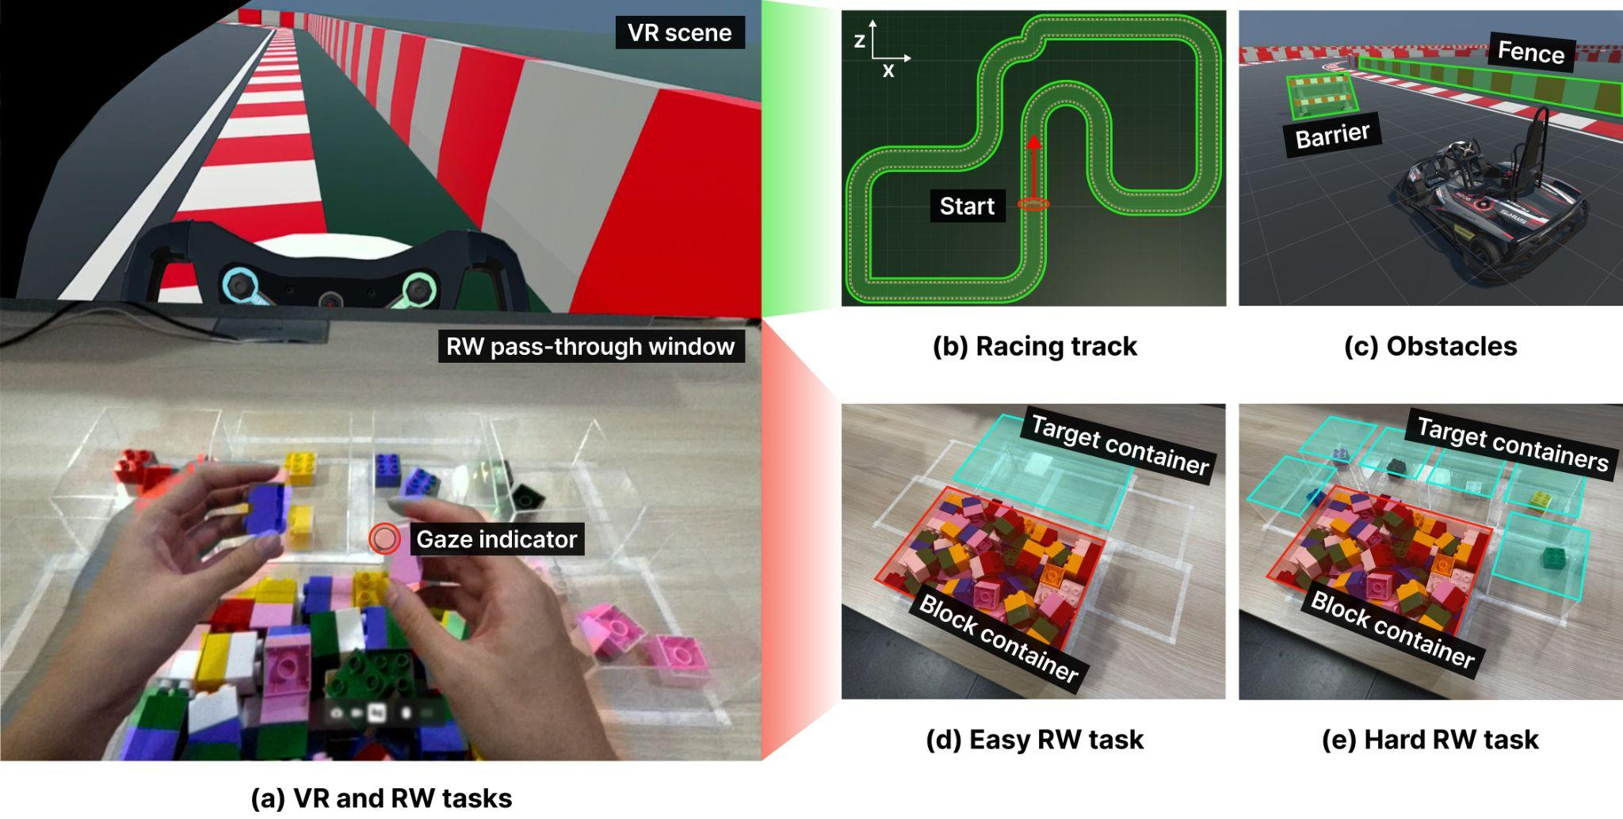
Fig 1. The cross-reality multitasking experimental setting, including (a) the VR scene (upper potion of the visual field) and RW pass-through window (lower potion of the visual field). In the VR task, participants controlled a virtual vehicle to travel along a rounded track (b), avoiding hitting any obstacles (c). In the RW task, participants separated and sorted LEGO blocks into target containers without distinguishing colors (easy condition (d)) and by colors (hard condition (e)). The gaze indicator was presented in-real time. Note: For demonstration purposes, the VR scene was captured from the right-eye view.

Experimental design and procedure
We used a within-subject mixed design, with two factors: mode and difficulty. In benchmarkR, the only task was to separate and sort blocks. In benchmarkV, the only task was to control the virtual vehicle with a controller. Mode included RW monotasking condition (benchmarkR), VR monotasking condition (benchmarkV) and 5 multitasking condiitons (Gaze, Head, Body, Face and the Controller baseline). Except for benchmarkV, each mode was perfomred under two difficulty of the RW task (easy, hard). In total, it provided 13 conditions.
After a brief introduction, consent and basic information collection, eye tracking was calibrated for each participant. The order of monotasking and multitasking sessions was counterbalanced. Condition orders within each session were randomized. Before each condition, participants recorded a 3-minute resting heart rate and then wore the headset to complete the Simulator Sickness Questionnaire (SSQ) and multiple fatigue and pain (MFP) questionnaires, which served as baseline measures. During each condition, participants were instructed to sort as many blocks as possible while controlling the virtual vehicle, avoiding collisions with barriers and fences, and traveling as far as possible within the given time (VR task). Participants were instructed to separate the blocks using both hands and one block at a time. In the controller condition, they were asked to pick up the controller to control the virtual vehicle, and pause the RW task while steering the virtual vehicle, ensuring both hands were occupied in RW task, the same setting as other modalities for better comparison. All multitasking conditions were recorded with gaze indicators captured in both the VR scene and the RW pass-through window. Each condition lasted 90 s, during which participants’ heart rates were continuously monitored. They were encouraged to pause or terminate the experiment if they experienced significant discomfort. Immediately after each condition, participants completed the same two questionnaires and the RAW NASA-TLX, and then proceeded to the next condition after a 3-min rest period. Upon finishing all conditions, a 5-minute interview was conducted. The experiment lasted 2 hours. The procedure was presented in Figure 2.

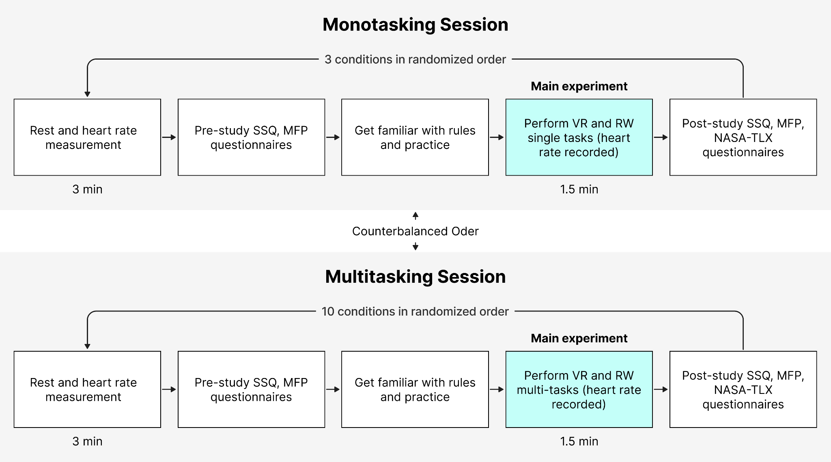
Fig 2. The experimental procedure comprised monotasking sessions (three conditions) and multitasking sessions (ten conditions). Before each condition, participants completed a 3-minute rest period during which their heart rate was monitored. They also completed baseline Simulator Sickness Questionnaire (SSQ) and Mental Fatigue Perception (MFP) questionnaires. Following a familiarization phase, the main experimental task lasted 90s. Upon completion, participants filled out post-study SSQ, MFP, and NASA-TLX questionnaires.

Measurement and Analysis
We measured a comprehensive set of performance, physiological, and subjective variables. Performance of the VR task was measured by distance traveled ($D$), averaged speed ($avgSpd$), number of collisions ($NoC)$, total durations of collision ($ToC$), and the smoothness of traveling paths using the spectral arc-length ($SAL$) metric (Balasubramanian et al., 2012). Additionally, the number and total durations of activation of all commands ($NoA$, $ToA$) were recorded. Performance of the RW task was measured by blocks successfully sorted ($B$). Physiological data included the number of gaze switches and total durations on the RW task ($NoG$, $ToG$) and heart rate ($HR$). Subjective data included perceived workload ($WL$) based on the RAW NASA-TLX questionnaire (1-7 points), cybersickness ($CS$) based on the Simulator Sickness Questionnaire ($SSQ$, 1-3 points)(Kennedy et al., 1993), muscle fatigue and pain ($MFP$) (hand, arm, neck, upper back, lower back, head and face) based on a Borg C-10 questionnaire (Vlahovic et al., 2024), task priority, mode ranking, and interview responses.
The raw data for each participant included files from the VR task automatically exported from Unity (basics, operations, collisions, and trajectory), gaze recordings, data from the RW task (sorted blocks), and subjective responses recorded by the researchers. Raw data are available in the following link: xxx. Gaze recordings were manually analyzed by two researchers to identify switch events. The trajectories of each mode and difficulty level across all participants are available in Appendix XX. $SAL$ was calculated from the vehicle's x-z coordinates across frames (60Hz). All files were combined into a single dataset preceding into analysis, comprising 900 rows (15 conditions × 2 time points x 30 participants).
Dependent variables were divided into four types, including continuous data ($D$, $avgSpeed$, $ToC$, $ToA$, $ToG$, $HR$, $mean WL score$, $SSQ scores$, $mean MFP score$), discrete data ($NoC$, $NoA$, $NoG$, $B$), ordinal data ($WL submetrics$, $MFP submetrics$, mode ranking) and nominal data (task priority). Normality tests, plots and histograms were conducted to check continuous data, all violated parametric assumptions, such as non-normal residuals and heteroscedasticity, even after trials of data transformation. Therefore, for all continuous data, we adopted the same rank-based nonparametric tests used for ordinal data. Specifically, we employed the Aligned Rank Transform (ART) ANOVA (Wobbrock et al., 2011) with the ART-C method (Elkin et al., 2021) to examine main effects and interactions using Type-III tests in two-way repeated-measures designs. For one-way repeated-measures designs, we used the Friedman test, and pairwise comparisons were conducted using the Wilcoxon signed-rank test. For discrete count data, we employed the mixed negative binomial regression model (Hilbe, 2011), using glmmTBM package (Brooks et al., 2017) to account for zero values and overdispersion. For nominal data, we employed the mixed effects multinomial logistic regression model (Kwak & Clayton-Matthews, 2002), using mclogit package (Martin Elff, 2010).
The analysis included three parts. First, we compared $SSQ$, $MFP$ and $HR$ between pre-study and post-study conditions with time as the within-subject factor. Second, we compared other modes with benchmarkV with mode as the within-subject factor. Third, we examined the mode × difficulty factorial design (excluding benchmarkV). For all analyses, post hoc pairwise comparisons were conducted using Bonferroni adjustment. Data analysis was performed using R, with a significance level set at $p=0.05$. Lastly, interview responses were informally coded to identify major themes, complementing quantitative results.

Results
Table xx presents the descriptive statistics for all dependent variables (except task priority) for each mode and difficulty level.

 | BenchmarkR |  |  | BenchmarkV |  | Controller |  |  | Gaze |  |  | Head |  |  | Body |  |  | Face
Difficulty | Easy | Hard |  | Control |  | Easy | Hard |  | Easy | Hard |  | Easy | Hard |  | Easy | Hard |  | Easy | Hard
VR Performance
$D$ (m) | / | / |  | 834.32 (±41.77) |  | 687.01 (±96.51) | 643.88 (±106.74) |  | 696.91 (±105.81) | 580.31 (±87.60) |  | 786.58 (±108.37) | 658.01 (±91.13) |  | 768.63 (± 81.43) | 621.61 (± 112.34) |  | 687.01 (±188.90) | 548.36 (±166.50)
$avgSpd$ (km/s) | / | / |  | 32.19 (±1.37) |  | 27.41 (±3.15) | 25.72 (±3.67) |  | 28.10 (±3.11) | 23.97 (±3.10) |  | 30.72 (±4.21) | 26.65 (±3.49) |  | 30.24 (±3.09) | 25.33 (±4.11) |  | 27.60 (±6.18) | 22.66 (±5.90)
$NoC$ | / | / |  | 0.9 (±0.92) |  | 4.27 (±1.84) | 4.53 (±1.80) |  | 4.43 (±1.94) | 7.27(±2.35) |  | 1.93 (±2.29) | 5.63 (±2.62) |  | 1.83 (±1.95) | 5.83 (±3.31) |  | 2.9 (±1.95) | 6.77 (±3.19)
$ToC$ (s) | / | / |  | 0.57 (±0.80) |  | 5.26 (±4.78) | 8.92 (±7.46) |  | 3.91 (±2.22) | 9.58 (±6.14) |  | 1.57 (±3.43) | 4.90 (±3.34) |  | 1.53 (±2.42) | 7.26 (±6.32) |  | 5.26 (±4.78) | 8.92 (±7.46)
$SAL$ | / | / |  | -164.90 (±33.30) |  | -232.66 (±37.42) | -249.09 (±29.22) |  | -250.64 (±37.02) | -256.94 (±38.67) |  | -190.58 (±52.95) | -253.51 (±27.12) |  | -212.58 (±56.72) | -249.10 (±29.29) |  | -237.01 (±48.51) | -255.76 (±40.06)
VR Operation
$NoA$ | / | / |  | 68.20 (±20.50) |  | 55.43 (±19.36) | 51.33 (±17.59) |  | 50.00 (±9.28) | 43.87 (±7.82) |  | 40.70 (±10.01) | 35.43 (±7.17) |  | 31.97 (±7.11) | 30.40 (±6.36) |  | 43.43 (±11.28) | 50.60 (±11.04)
$ToA$ (s) | / | / |  | 0.59 (±0.12) |  | 0.66 (±0.11) | 0.66 (±0.15) |  | 0.68 (±0.12) | 0.63 (±0.11) |  | 1.03 (±0.19) | 1.03 (±0.20) |  | 1.29 (±0.18) | 1.26 (±0.26) |  | 0.66 (±0.53) | 0.66 (±0.19)
RW performance
$B$ | 61.15 (±8.95) | 38.93 (±6.58) |  | / |  | 17.77 (±6.34) | 11.97 (±6.33) |  | 31.98 (±8.56) | 12.30 (±4.64) |  | 38.57 (±8.06) | 20.12 (±6.12) |  | 36.88 (±7.22) | 18.17 (±6.49) |  | 35.20 (±8.14) | 17.45 (±5.56)
Gaze
$NoG$ | / | / |  | / |  | 11.73 (±11.69) | 15.97 (±5.96) |  | 2.47 (±5.31) | 17.70 (±7.08) |  | 3.73 (±7.08) | 30.00 (±7.48) |  | 4.17 (±8.69) | 26.67 (±7.75) |  | 3.57 (±3.72) | 29.53 (±7.62)
$ToG$ (s) | / | / |  | / |  | 12.44 (±13.59) | 30.88 (±10.74) |  | 3.23 (±7.09) | 26.72 (±10.39) |  | 4.74 (±13.30) | 43.97 (±15.88) |  | 4.19 (±12.78) | 40.45 (±16.95) |  | 2.51 (±2.87) | 39.56 (±14.83)
Δ$HR$ | 8.30 (±6.82) | 8.63 (±5.92) |  | 0.40 (±4.79) |  | 1.10 (±4.43) | 3.27 (±4.59) |  | 4.83 (±7.00) | 1.73 (±3.67) |  | 6.57 (±7.82) | 5.10 (±4.96) |  | 6.93 (±6.80) | 5.77 (±5.14) |  | 6.10 (±6.98) | 3.93 (±4.09)
NASA-TLX
Mental demand | 8.33 (±14.35) | 33.33 (±23.97) |  | 31.67 (±21.60) |  | 47.22 (±24.79) | 63.89 (± 23.60) |  | 50.00 (± 28.03) | 69.44 (± 22.78) |  | 35.00 (± 19.25) | 53.33 (± 27.82) |  | 35.56 (± 23.05) | 57.78 (± 24.66) |  | 37.22 (±23.03) | 57.22 (±24.24)
Physical demand | 31.11 (±25.42) | 29.44 (±22.18) |  | 26.67 (±24.60) |  | 41.11 (±23.46) | 45.00 (±24.43) |  | 38.89 (±27.80) | 45.56 (±25.50) |  | 47.78 (±26.16) | 51.11 (±28.68) |  | 52.78 (±23.19) | 59.44 (±26.51) |  | 36.67 (±26.77) | 44.44 (±27.45)
Temporal demand | 42.22 (±29.27) | 44.44 (±29.47) |  | 24.44 (±24.66) |  | 65.56 (±20.50) | 67.78 (±23.13) |  | 48.33 (±24.51) | 65.00 (±26.02) |  | 34.44 (±25.50) | 51.67 (±26.75) |  | 41.67 (±28.28) | 60.00 (±28.57) |  | 36.67 (±23.33) | 53.33 (±24.53)
Performance | 24.44 (±14.34) | 42.22 (±21.77) |  | 32.78 (±24.56) |  | 52.78 (±19.12) | 58.89 (±18.43) |  | 45.56 (±17.47) | 65.56 (±23.54) |  | 31.11 (±18.94) | 52.78 (±20.57) |  | 32.78 (±18.30) | 53.89 (±17.33) |  | 39.44 (±20.29) | 56.11 (±18.82)
Effort | 53.89 (±28.93) | 59.44 (±23.03) |  | 51.11 (±23.54) |  | 69.44 (±21.03) | 72.22 (±20.68) |  | 66.67 (±21.44) | 73.33 (±21.71) |  | 58.89 (±25.04) | 66.67 (±23.16) |  | 59.44 (±23.44) | 70.00 (±23.33) |  | 60.00 (±26.48) | 70.00 (±21.62)
Frustration | 5.56 (±10.11) | 15.56 (±19.04) |  | 23.89 (±22.18) |  | 34.44 (±25.50) | 40.00 (±22.99) |  | 28.89 (±20.03) | 42.22 (±27.24) |  | 9.44 (±11.32) | 26.11 (±17.33) |  | 15.56 (±16.91) | 35.56 (±23.46) |  | 21.11 (±22.29) | 38.33 (±22.38)
Weighted rating | 27.5 9 (±13.92) | 37.41 (±15.38) |  | 31.76 (±14.71) |  | 51.76 (±15.17) | 57.96 (±15.35) |  | 46.39 (±16.35) | 60.19 (±16.50) |  | 36.11 (±12.36) | 50.28 (±16.35) |  | 39.63 (±14.26) | 56.11 (±17.56) |  | 38.52 (±15.78) | 53.24 (±15.98)
SSQ
ΔNausea | -0.32 (±1.74) | 1.59 (±5.65) |  | 6.04 (±19.64) |  | 1.91 (±8.08) | 0.32 (±3.95) |  | 1.27 (±4.14) | 0.00 (±0.00) |  | 2.23 (±7.38) | 1.91 (±4.62) |  | 3.18 (±7.65) | 1.59 (±4.40) |  | 0.00 (±0.00) | 0.00 (±0.00)
ΔOculomotor | 0.25 (±4.21) | 4.80 (±7.31) |  | 5.56 (±17.00) |  | 1.52 (±8.30) | 1.26 (±5.30) |  | 6.82 (±12.00) | 6.57 (±10.48) |  | 1.52 (±5.42) | 0.76 (±7.00) |  | 1.52 (±4.18) | 2.78 (±5.80) |  | 3.28 (±6.51) | 2.27 (±5.32)
ΔDisorientation | 3.71 (±9.63) | 10.21 (±15.48) |  | 30.16 (±44.33) |  | 6.50 (±14.50) | 6.96 (±10.18) |  | 12.53 (±19.80) | 7.42 (±17.04) |  | 10.67 (±16.63) | 4.18 (±12.74) |  | 10.21 (±13.65) | 13.92 (±20.68) |  | 4.64 (±8.44) | 4.18 (±12.21)
ΔTotal | 1.00 (±4.39) | 5.73 (±6.86) |  | 13.21 (±27.30) |  | 3.24 (±10.29) | 2.62 (±5.48) |  | 7.23 (±11.07) | 5.24 (±9.40) |  | 4.49 (±8.12) | 2.24 (±6.99) |  | 4.74 (±7.01) | 5.73 (±7.53) |  | 2.87 (±4.25) | 2.24 (±4.56)
ΔTotal MFP score | 2.55 (±3.77) | 1.60 (±3.32) |  | 1.10 (±2.06) |  | 1.90 (±4.52) | 1.47 (±4.10) |  | 1.57 (±3.28) | 1.03 (±4.09) |  | 2.60 (±5.10) | 2.57 (±4.45) |  | 2.70 (±4.92) | 2.50 (±5.12) |  | 1.57 (±2.43) | 1.83 (±3.31)
Ranking | / | / |  | / |  | 3.70 (±1.37) | 3.57 (±1.36) |  | 3.73 (±1.20) | 3.90 (±1.18) |  | 2.00 (±1.31) | 1.90 (±1.24) |  | 2.73 (±0.98) | 2.37 (±0.93) |  | 2.83 (±1.46) | 3.27 (±1.34)

Pre-study vs. experiment
Significant differences were observed on $SSQ$, $MFP$ scores and $HR$ between pre-study and experiment (see Table xx). For $MFP$, significant differences were found across all fatigue measures except for the upper back, whereas no significant differences were observed for pain measures. The result indicated that participants experienced greater simulator sickness, muscle fatigue and with a higher heart rate during and after the experiment.

Table X. Results of Wilcoxon signed-rank tests comparing pre-study and post-study conditions for $SSQ$, $MFP$ scores, and $HR$. Note. only statistically significant measures are reported.
 | $W$ | $p$
$SSQ$
$nausea$ | 105.00 | <0.01
$oculomotor$ | 242.00 | <0.001
$disorientation$ | 351.00 | <0.001
$total$ | 351.00 | <0.001
$MFP$
$hand fatigue$ | 55.00 | <0.01
$arm fatigue$ | 136.00 | <0.001
$neck fatigue$ | 210.00 | <0.001
$shoulder fatigue$ | 36.00 | <0.05
$lower back fatigue$ | 36.00 | <0.05
$head fatigue$ | 91.00 | <0.01
$facial fatigue$ | 91.00 | <0.01
$total$ | 378.00 | <0.001
Heartrate
$HR$ | 465.00 | <0.001

VR task performance and operations

VR performance
The performance of the VR task for each mode is shown in Figure xx. benchmarkV had the largest $D$ and $avgSpeed$ and the lowest $NoC$ and $ToC$, resulting in the largest $SAL$ (larger is smoother). The differences compared with other modes in both difficulty conditions were also significant on all metrics ($all p<0.001$). It indicated that participants performed significantly worse on the VR task when performing the RW task simultaneously. However, post hoc comparisons revealed no significant difference between head and benchmarkV in the easy condition across all metrics, except for $NoC$.

Across multitasking modes, head and body had the largest $D$, $avgSpd$, $SAL$ and the smallest $NoC$ and $ToC$ (see Fig. xx). Significant main effects of mode and difficulty, and their interaction, were observed (see Table xx). Post hoc comparisons revealed significant differences across all metrics ($all p<0.05$) between simple and hard conditions for all modes except for controller ($NoC$) and gaze ($SAL$). Then, significant differences were observed in all metrics between head and other modes except for body in the easy condition ($all p<0.01$, except head & face ($NoC$); head & controller ($SAL$)). However, in the hard condition, significant differences were observed only between controller & gaze, face in $D$, $NoC$ (all $p<0.05$), and head & gaze, face in $D$, $avgSpd$ (all $p<0.05$).

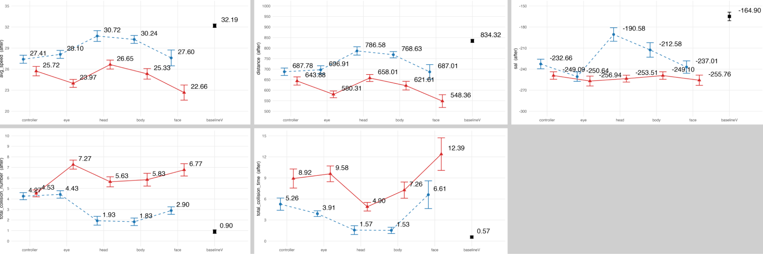

Table X. Summary of the two-way ART-ANOVA ($F$) and mixed negative binomial model ($x^{2}$) (mode × difficulty) on traveled distance ($D$), averaged spped ($avgSpd$), number of collision ($NoC$), duration of collision ($ToC$) and trajectory smoothness ($SAL$).
 | Mode |  |  | Difficulty |  |  | Mode x Difficulty
 | $F_{(4,261)}^{}$ | $x_{4}^{2}$ | $p$ | $F_{(1,261)}^{}$ | $x_{1}^{2}$ | $p$ | $F_{(4,261)}^{}$ | $x_{4}^{2}$ | $p$
$D$ | 12.78 |  | < 0.001 | 163.22 |  | < 0.001 | 5.45 |  | < 0.001
$avgSpd$ | 13.51 |  | < 0.001 | 163.85 |  | < 0.001 | 5.16 |  | < 0.001
$NoC$ |  | 436.31 | < 0.001 |  | 135.28 | < 0.001 |  | 92.42 | < 0.001
$ToC$ | 16.56 |  | < 0.001 | 100.11 |  | < 0.001 | 1.61 |  | 0.17
$SAL$ | 6.54 |  | < 0.001 | 39.87 |  | < 0.001 | 4.83 |  | < 0.001
The results indicated that the head outperformed other modes under both the simple and hard task conditions. head even achieved near-optimal VR task performance (compared with benchmarkV) in the simple condition. However, task difficulty strongly influenced VR task performance. For example, the performance gaps between head, body and other modes were reduced under the hard condition, evident in $NoC$ and $SAL$ (See Figure xx1-3). Notably, the effect of task difficulty on controller was relatively small, as it performed poorly in both conditions.

VR Operation
The overall activation of all commands (left, right, back) for each mode is shown in Figure xx. benchmarkV had the largest $NoA$ and smallest $ToA$. The differences compared with other modes in both difficulty conditions were also significant on both metrics ($both p<0.001$). However, post hoc comparisons revealed no significant difference between benchmarkV and gaze, controller in the easy condition in $ToA$. Among other hands-gree modes, controller, eye and face had larger $NoA$ and smaller $ToA$ than head and body. Significant main effects of mode, difficulty, and their interaction were observed (see Table xx). Post hoc comparisons revealed significant differences between all modes in $ToA$ (except eye & controller) and $NoA$ (excpet eye & controller, face; head & face -easy; gaze & controller, face; head & body-hard). However, no significant differences were observed on both metrics between easy and hard tasks in each mode.

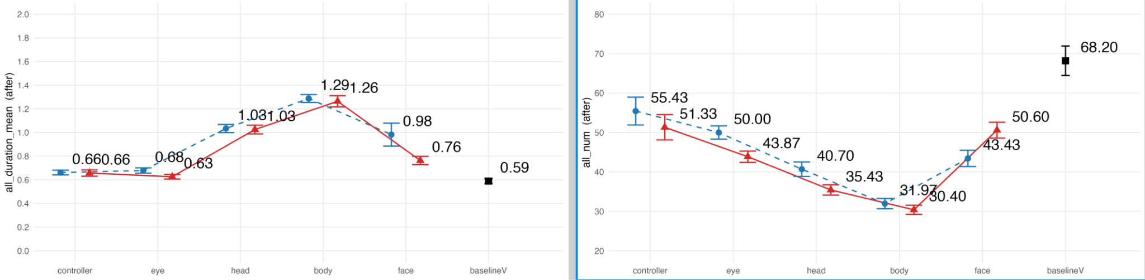

Table X. Summary of the two-way ART-ANOVA ($F$) and mixed negative binomial model ($x^{2}$) (mode × difficulty) on VR command number ($NoA$) and duration ($ToA$) of command activation.
 | Mode |  |  | Difficulty |  |  | Mode x Difficulty
 | $F_{(4,261)}^{}$ | $x_{4}^{2}$ | $p$ | $F_{(1,261)}^{}$ | $x_{1}^{2}$ | $p$ | $F_{(4,261)}^{}$ | $x_{4}^{2}$ | $p$
$NoA$ |  | 216.90 | < 0.001 |  | 3.75 | 0.053 |  | 18.54 | < 0.001
$ToA$ | 171.47 |  | < 0.001 | 12.30 |  | < 0.001 | 1.25 |  | 0.290
The results suggested that head and body exhibited lower frequency than controller, gaze and face, suggesting greater degree of movement and time required. However, the differences between difficulty levels were small, suggesting that participants adopted similar strategies for the VR task, with limited influence from varying RW task demands.

RW task performance
The performance of the RW task for each mode is shown in Figure xx. benchmarkR had the largest $B$.The differences compared with other modes in both difficulty conditions were also significant on all metrics ($all p<0.001$). It indicated that participants performed significantly worse on the VR task when performing the RW task simultaneously.

Across other modes (excluding benchmarkV), head had the largest $D$, followed by body, face and gaze, whist controller had the smallest. Significant main effects of mode and difficulty, and their interaction, were observed (see Table xx). Post hoc comparisons revealed head, body, and face performed significantly differently from controller and gaze in both task difficulty conditions ($all p<0.001$, except gaze & body -easy $p<0.05$), except for body & gaze -easy. However, no significantly differences were observed within head, body and face. Additionally, significant differences were observed between two task difficulty conditions in each mode ($all p<0.001$).

The results suggested that head outperformed other hands-free mode in RW task performance, consistent with the findings from VR task performance. However, the differences between head, body and face were relatively small. The controller baseline, on the other hand, exhibited the poorest performance. Additionally, the influence of RW task difficulty on performance was evident, as participants sorted substantially more blocks in the easy condition. However, this performance improvement was less pronounced in the controller baseline, which was expected, as participants could not manipulate the blocks and drive simultaneously.

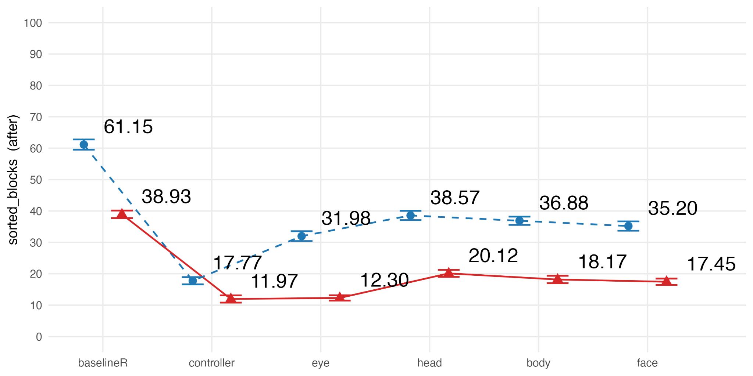
Table X. Summary of the mixed negative binomial model (mode × difficulty) on sorted blocks ($B$).
 | Mode |  | Difficulty |  | Mode x Difficulty
 | $x_{5}^{2}$ | $p$ | $x_{1}^{2}$ | $p$ | $x_{5}^{2}$ | $p$
$B$ | 1390.06 | < 0.001 | 831.05 | < 0.001 | 66.39 | < 0.001

Physiological data

Gaze
Gaze ($NoG$, $ToG$) for each mode is shown in Figure xx. Regarding gaze behaviors, controller yielded the longest duration and most switches on the RW task under easy condition, while under the hard condition, head became dominant on both measures. Significant main effects of mode and difficulty, and their interaction, were observed (see Table xx). Post hoc comparisons revealed significant differences between controller and gaze, head, body, face across both metrics under easy condition ($all p<0.001$). However, no significant differences were observed between gaze, head, body and face. Under hard condition, head, body, and face performed significantly differently from controller and gaze ($all p<0.05$), except for eye & body ($NoG$). However no significant differences were observed between head, body and face, as well as controller and gaze. Additionally, significant differences were observed between two task difficulty conditions in each mode ($all p<0.05$).

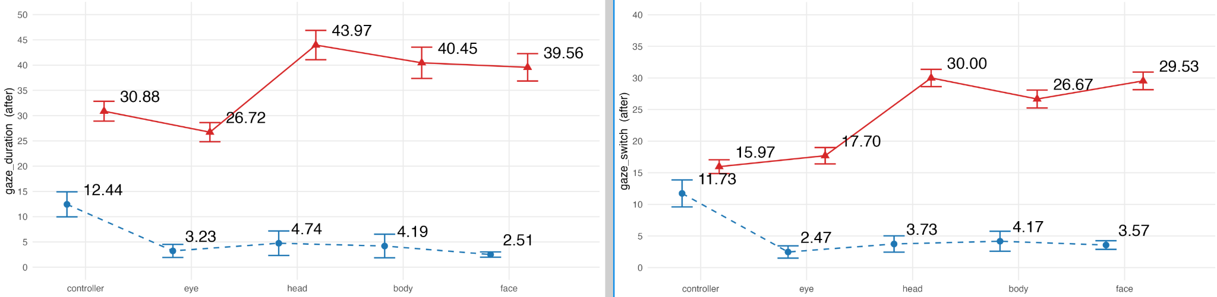

Table X. Summary of the two-way ART-ANOVA ($F$) and mixed negative binomial model ($x^{2}$) (mode × difficulty) on number of gaze switch ($NoG$) and duration of gaze ($ToG$) on the RW task.
 | Mode |  |  | Difficulty |  |  | Mode x Difficulty
 | $F_{(4,261)}^{}$ | $x_{4}^{2}$ | $p$ | $F_{(1,261)}^{}$ | $x_{1}^{2}$ | $p$ | $F_{(4,261)}^{}$ | $x_{4}^{2}$ | $p$
$NoG$ |  | 38.23 | < 0.001 |  | 459.48 | < 0.001 |  | 88.56 | < 0.001
$ToG$ | 11.47 |  | < 0.001 | 1112.29 |  | < 0.001 | 25.08 |  | < 0.001

The results indicated that under the easy condition, the VR task captured nearly all visual attention in all hands-free modes. Consequently, the RW task was performed primarily through peripheral vision or blindly. However, the RW task required more visual attention in the controller mode. The trend flipped in the hard condition as the RW task drew much more attention. The Head condition showed the greatest attentional focus on the RW task, and the proportions of attention allocated to the VR and RW tasks were nearly equal. However, the differences among head, body, and face were small. In contrast, attentional increase on the RW task was much less in controller and gaze, indicating that these two modes demanded greater cognitive resources for VR operation, thereby limiting the ability to flexibly reallocate attention to the RW task. Overally, gaze focus was more in the VR task in both difficulty condiitons, indicating a visual attentional bias towards the VR task during the cross-reality multitasking.

Heart rate

Heart rate difference between pre-study and during experiment ($ΔHR$) is shown in Figure xx. benchmarkR had the largest $HR$ difference in both difficulty conditions, whilst benchmarkV had the smallest. Post hoc comparisons revealed significant differences between benchmarkV and all multitasking modes in both difficulty conditions (all $p<0.05$) except for benchmarkV & controller -easy and benchmarkV & controller, gaze -hard.

Across other modes (excluding benchmarkV), benchmarkV had the highest $ΔHR$ in both task difficulty conditions. Significant main effects of mode and mode*difficulty were observed (see Table xx). Post hoc comparison revealed significant differences between controller and all other modes under easy condition (all $p<0.001$, except controller & eye $p<0.05$), and between gaze and benchmarkR, head and body under had condition (all $p<0.05$). The differences compared with benchmarkV in both difficulty conditions were significant for all modes ($all p<0.05$) except for controller & benchmarkV -easy, hard and eye & benchmarkV -hard. Interestingly, the increase in $HR$ was generally smaller under the hard condition compared to the easy condition.

The results suggest that the increase in heart rate was primarily driven by the degree of body movement rather than task difficulty. Participants sorted more blocks in the easy condition than in the hard condition (see Figure XX), which required greater physical involvement and consequently led to a larger increase in heart rate. A similar pattern was observed across modes. Participants sorted the highest number of blocks in benchmarkR, therefore resulted in the highest $HR$. In contrast, benchmarkV, which primarily involved vehicle control using a handheld controller elicited the lowest $HR$. For hands-free modes, $HR$ increase was larger in body, head and face compared to gaze, reflecting greater body or muscle movement.
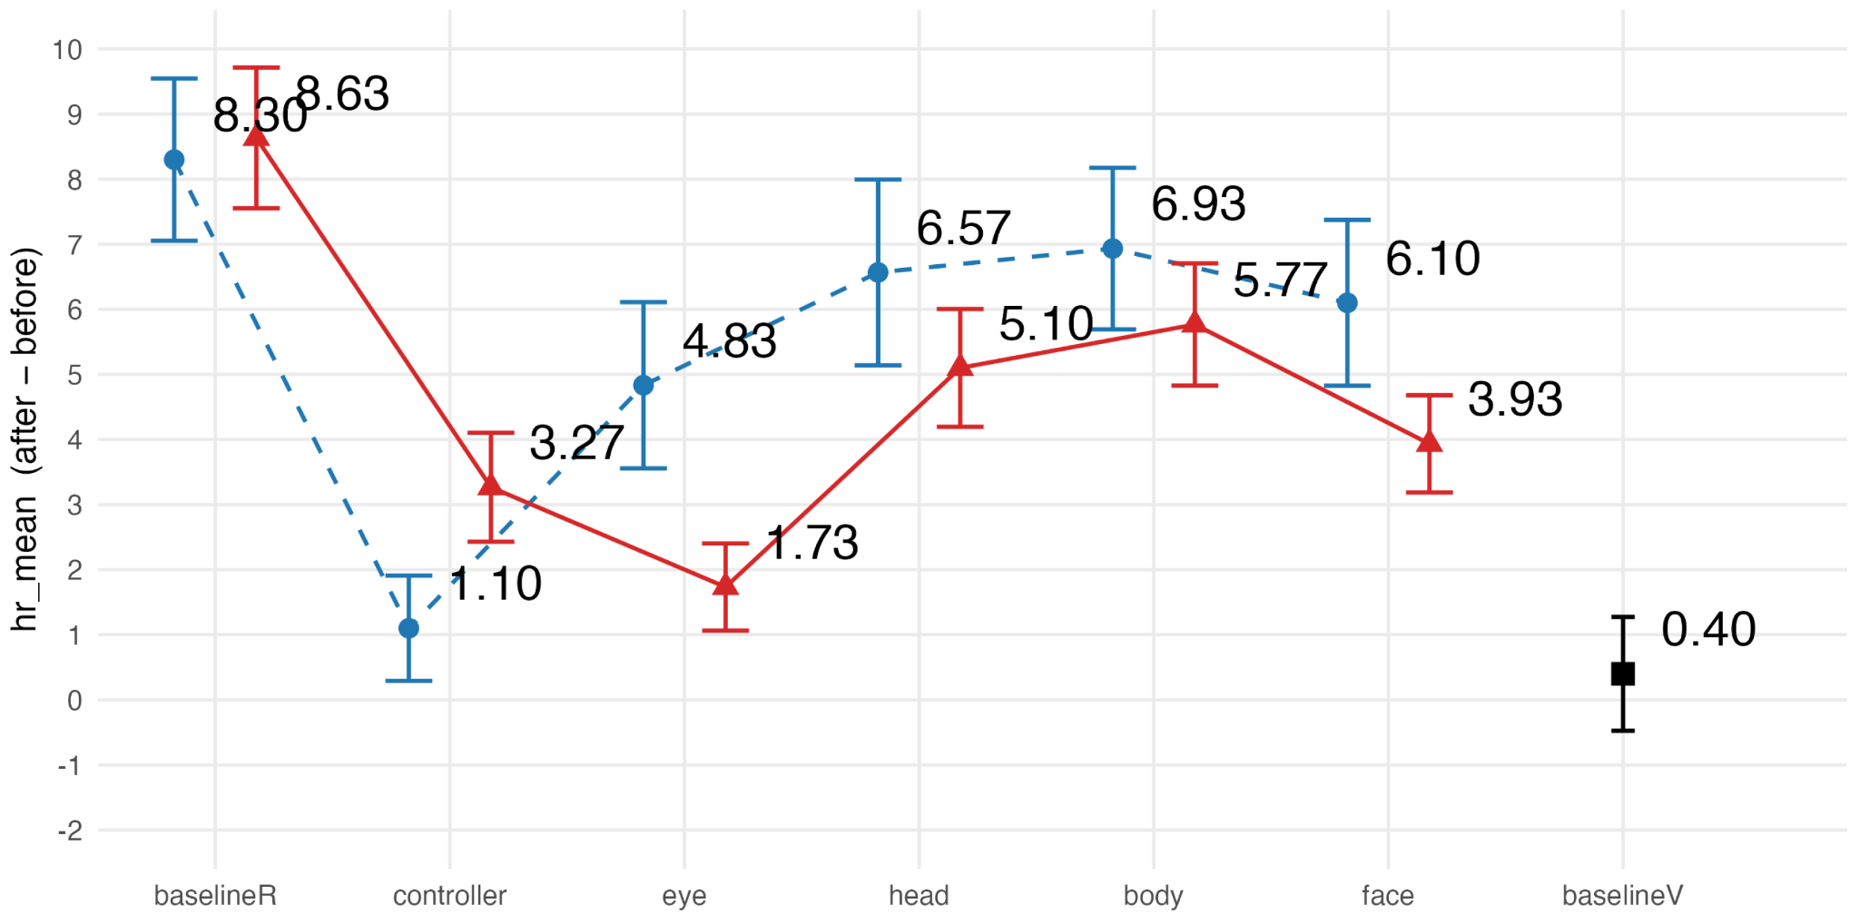
Table X. Summary of the two-way ART-ANOVA (mode × difficulty) on heart rate difference between pre-study and during experiment ($ΔHR$).
 | Mode |  | Difficulty |  | Mode x Difficulty
 | $F_{(5,319)}^{}$ | $p$ | $F_{(1,319)}^{}$ | $p$ | $F_{(5,319)}^{}$ | $p$
$ΔHR$ | 15.12 | < 0.001 | 1.76 | 0.19 | 2.44 | < 0.05

Questionnaire response

NASA-TLX questionnaire
The NASA-TLX scores were converted into original 0-100 range (lower is better) to facilitate comparison between related studies. The weighted rating (mean) and subscale subjective workload scores are presented in Figure xx. It can be seen that the perceived workload of benchmarkR and benchmarkV was similar. However, multitasking included a higher workload than monotasking conditions, with a greater increase under difficulty compared to simple task conditions.

Significant differences were observed in weighted rating and most submeasures comparing benchmarkV and multitasking modes (all $p<0.05$). However, post hoc comparisons revealed no significant differences between benchmarkV and head, body, face excluding physical demand and temporal demand (benchmarkV & body) under easy condition.

Across other modes (excluding benchmarkV), controller and gaze had a higher rating than others in all metrics except for physical demand, where body demanded the highest. Significant main effects of mode, difficulty and their interaction were observed (see Table xx). Post hoc comparison revealed significant differences between benchmarkR and all modes in mental demand and weighted rating (all $p<0.001$). However, no significant differences were observed between benchmarkR & head in frustration, and benchmarkR & eye, face in physical demand. Additionally, significant differences were observed between controller and all modes in temporal demand and performance (except for controller & gaze) under easy condition (all $p<0.01$).

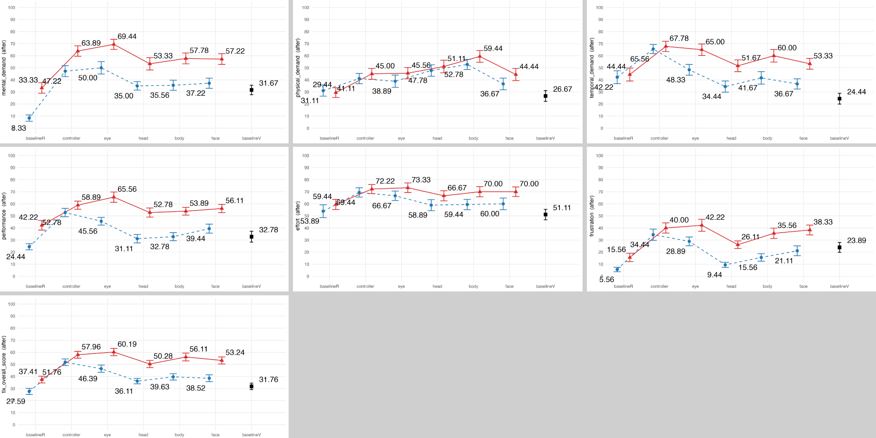

Table X. Summary of the two-way ART-ANOVA (mode × difficulty) on weighted and sub NASA-TLX measures.
 | Mode |  | Difficulty |  | Mode x Difficulty
 | $F_{(5,319)}^{}$ | $p$ | $F_{(1,319)}^{}$ | $p$ | $F_{(5,319)}^{}$ | $p$
$mental demand$ | 39.13 | < 0.001 | 130.84 | < 0.001 | 0.51 | 0.77
$physical demand$ | 13.16 | < 0.001 | 4.36 | < 0.05 | 0.45 | 0.81
$temporal demand$ | 15.63 | < 0.001 | 41.71 | < 0.001 | 2.63 | < 0.05
$performance$ | 17.65 | < 0.001 | 101.12 | < 0.001 | 2.56 | < 0.05
$effort$ | 5.45 | < 0.001 | 19.71 | < 0.001 | 0.49 | 0.79
$frustration$ | 24.85 | < 0.001 | 57.19 | < 0.001 | 1.51 | 0.19
$weighted rating$ | 30.52 | < 0.001 | 108.31 | < 0.001 | 1.90 | 0.09

The results indicated the strong cross-influence of multitasking and task difficulty on perceived workload. For multitasking modes, head, body and face induced generally lower workload than controller and gaze. These three modes were comparable to benchmarkV under easy task condition. In contrast, gaze induced the highest workload in general. Controller had the highest temporal demand and was less influenced by task difficulty compared with the other modes. However, for physical demand, body showed the highest rating, while controller and gaze were comparably low, similar to benchmarkR, consistent with the results from heart rate.

SSQ questionnaire
The total $ΔSSQ$ scores and submeasures are presented in Figure xx. It can be seen that an increase in cybersickness was evident across all modes in both difficulty conditions (all $Δ>0$). Nevertheless, the changes did not reveal a consistent pattern between the easy and difficult task conditions.

Additionally, benchmarkV induced higher cybersickness in nausea, disorientation and total score than other modes. Post hoc comparisons revealed significant differences between benchmarkV and all multitasking modes in disorientation and total score under both task difficulty conditions (all $p<0.05$), except for benchmarkV & eye (disorientation-easy, total score) and benchmarkV & body (disorientation-hard, total score). However, no significant differences were observed in nausea and oculomotor.

Across other modes (excluding benchmarkV), significant main effects of mode, difficulty and their interaction were observed in oculomotor, disorientation and total score (see Table xx). Post hoc comparisons revealed significant differences only between gaze & body, controller in oculomotor (both $p<0.05$), and between gaze & benchmarkR, controller under easy task condition (both $p<0.05$).
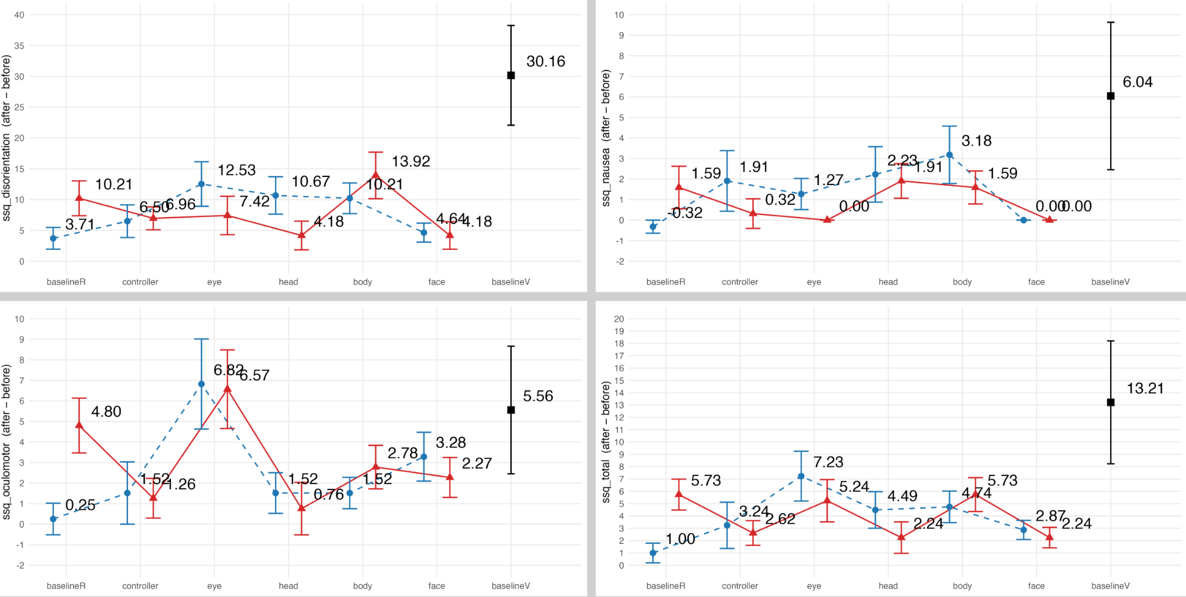

Table X. Summary of the two-way ART-ANOVA (mode × difficulty) on significant $SSQ$, including $Δ$oculomotor, $Δ$disorientation and $Δ$total score.
 | Mode |  | Difficulty |  | Mode x Difficulty
 | $F_{(5,319)}^{}$ | $p$ | $F_{(1,319)}^{}$ | $p$ | $F_{(5,319)}^{}$ | $p$
$Δ$$oculomotor$ | 4.93 | < 0.001 | 0.34 | 0.56 | 1.21 | 0.30
$Δ$$disorientation$ | 2.44 | < 0.05 | 0.02 | 0.88 | 2.34 | < 0.05
$Δ$$total score$ | 2.80 | < 0.05 | 0.38 | 0.54 | 2.79 | < 0.05

The results indicated that performing RW tasks via MR passthrough led to some cybersickness, especially regarding oculomotor symptoms. Additionally, cross-reality multitasking actually alleviated cybersickness compared to benchmarkV, especially regarding disorientation symptoms. All hands-free modes induced similar levels of cybersickness overall, except for gaze, which elicited more severe oculomotor symptoms. However, the influence of task difficulty on cybersickness was not evident.

MFP questionnaire
The total $ΔMFP$ scores were presented in Figure xx. It can be seen that benchmarkV induced the lowest score, whilst head and body were the highest. Pos hoc comparisons revealed significant differences between benchmarkV & body (lower back fatigue-hard, $p<0.05$), benchmarkV & face (facial fatigue-easy, hard, $p<0.05$),benchmarkV & body (total score-hard, $p<0.05$).

Across other modes (excluding benchmarkV), head and body had the highest total scores. Significant main effects of mode, difficulty and their interaction were observed in $MFP$ total score and submeasures (see Table xx). Pos hoc comparisons revealed significant differences between body & all modes except for head, and between head & controller (lower back fatigue, all $p<0.05$), between gaze & head (head fatigue-hard, $p<0.05$), between face & all modes (facial fatigue-easy, hard, all $p<0.001$), and between gaze & body (total score, $p<0.05$).
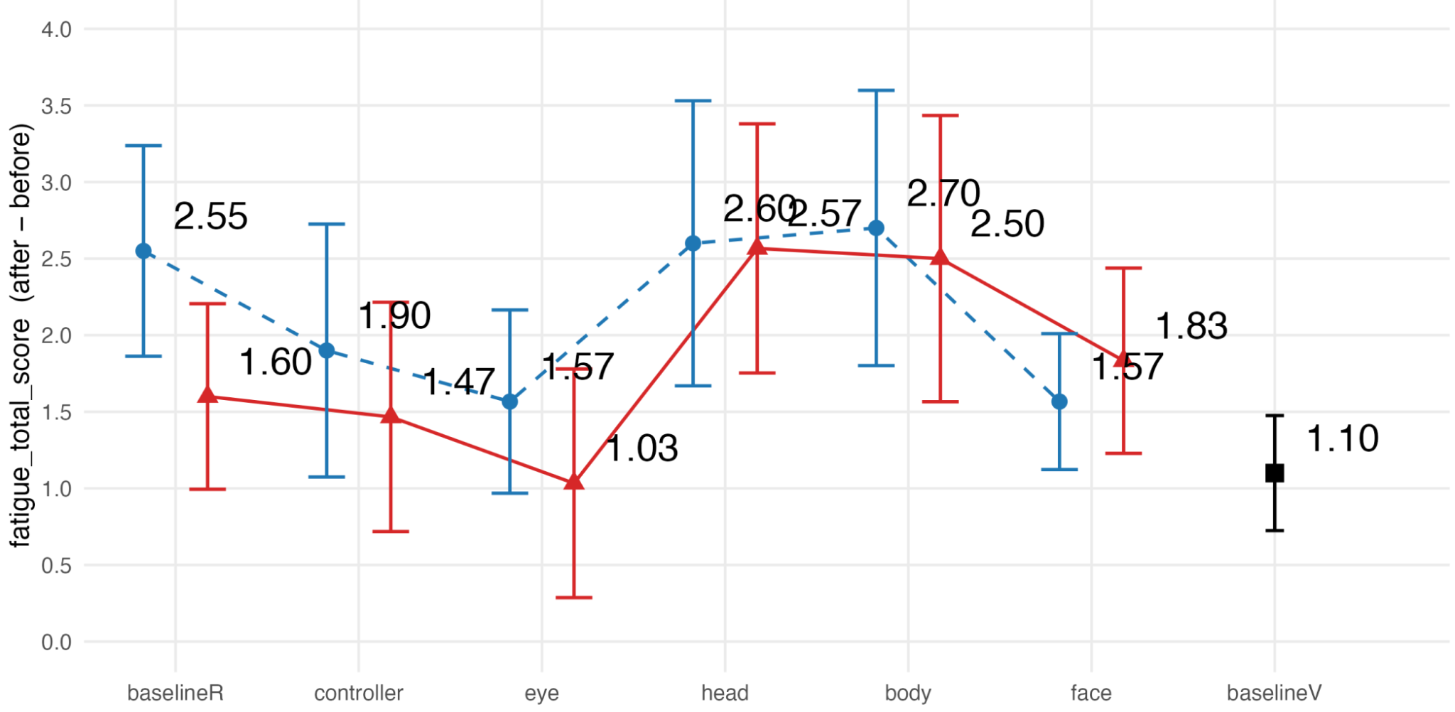

Table X. Summary of the two-way ART-ANOVA (mode × difficulty) on Δtotal $MFP$ and significant submeasures.
 | Mode |  | Difficulty |  | Mode x Difficulty
 | $F_{(5,319)}^{}$ | $p$ | $F_{(1,319)}^{}$ | $p$ | $F_{(5,319)}^{}$ | $p$
Muscle fatigue
$Δhand fatigue$ | 3.48 | < 0.01 | 217.32 | < 0.001 | 15.73 | < 0.001
$Δarm fatigue$ | 5.32 | < 0.001 | 32.98 | < 0.001 | 4.84 | < 0.001
$Δneck fatigue$ | 2.81 | < 0.05 | 0.75 | 0.75 | 0.22 | 0.22
$Δshoulder fatigue$ | 0.88 | 0.49 | 0.59 | 0.44 | 7.83 | < 0.001
$Δupper back fatigue$ | 1.85 | 0.10 | 54.02 | < 0.001 | 5.82 | < 0.001
$Δlower back fatigue$ | 6.96 | < 0.001 | 25.39 | < 0.001 | 1.76 | 0.12
$Δhead fatigue$ | 2.81 | < 0.05 | 1.05 | 0.31 | 5.84 | < 0.001
$Δfacial fatigue$ | 12.67 | < 0.001 | 97.46 | < 0.001 | 8.23 | < 0.001
Muscle pain
$Δneck pain$ | 2.13 | 0.06 | 7.22 | < 0.01 | 5.08 | < 0.001
$Δshoulder pain$ | 1.03 | 0.40 | 37.89 | < 0.001 | 9.81 | < 0.001
$Δupper back pain$ | 1.06 | 0.39 | 668.60 | < 0.001 | 49.62 | < 0.001
$Δlower back pain$ | 1.15 | 0.33 | 506.51 | < 0.001 | 55.21 | < 0.001
$Δhead pain$ | 2.08 | 0.07 | 371.08 | < 0.001 | 31.37 | < 0.001
$Δ$Total score | 5.47 | < 0.001 | 10.61 | < 0.01 | 1.94 | 0.09

The results revealed that head and body induced the highest levels of muscle fatigue among all hands-free modes, with markedly greater lower back fatigue in body,, possibly due to the greater extent of physical movement involved. This finding aligns with the observed increases in heart rate and perceived physical demand (NASA-TLX). Notably, the face mode elicited markedly higher facial fatigue compared to other modes, which may be attributed to the greater engagement of facial muscles during blinking and opening mouths.

Modality ranking
The ranking of each multitasking mode under each difficulty condition is shown in Figure xx. Among these modes, head received the highest ranking, whereas gaze received the lowest in both difficulty levels. A significant main effect of mode was observed (see Table xx). Post hoc comparisons revealed significant difference between head & all modes except for body, between body & gaze, face (all $p<0.001$).
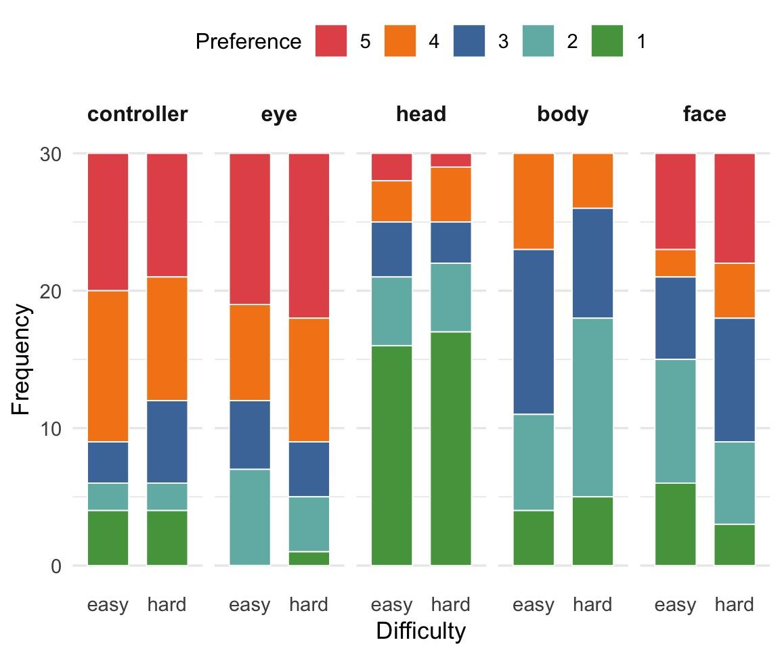
Table X. Summary of the two-way ART-ANOVA (mode × difficulty) on heart rate difference between pre-study and during experiment ($ΔHR$).
 | Mode |  | Difficulty |  | Mode x Difficulty
 | $F_{(5,319)}^{}$ | $p$ | $F_{(1,319)}^{}$ | $p$ | $F_{(5,319)}^{}$ | $p$
$ranking$ | 22.59 | < 0.001 | 0.00 | 0.95 | 1.03 | 0.39

The results revealed that most participants ranked the head mode as their first preference. Additionally, all hands-free modes were preferred over the controller mode, except for gaze. However, task difficulty had almost no influence on the ranking of modes.

Task priority
The selected task priority of each multitasking mode under each difficulty condition is shown in Figure xx. It can be seen that the VR task was mostly prioritized in all conditions. However, the RW task was more priorizted under difficult condition. Signifnicant main effects of mode and difficuly were observed in the Likelihood Ratio Test (LRT), with controller as the baseline mode and equal as the baseline priority category (see Table xx). Compared to controller, gaze significantly increased the likelihood of prioritizing VR (vs. Equal) ($p<0.05$), while other modes were not significant. Additionally, the hard task condition significantly reduced the likelihood of prioritizing VR (vs. Equal) ($p<0.001$).
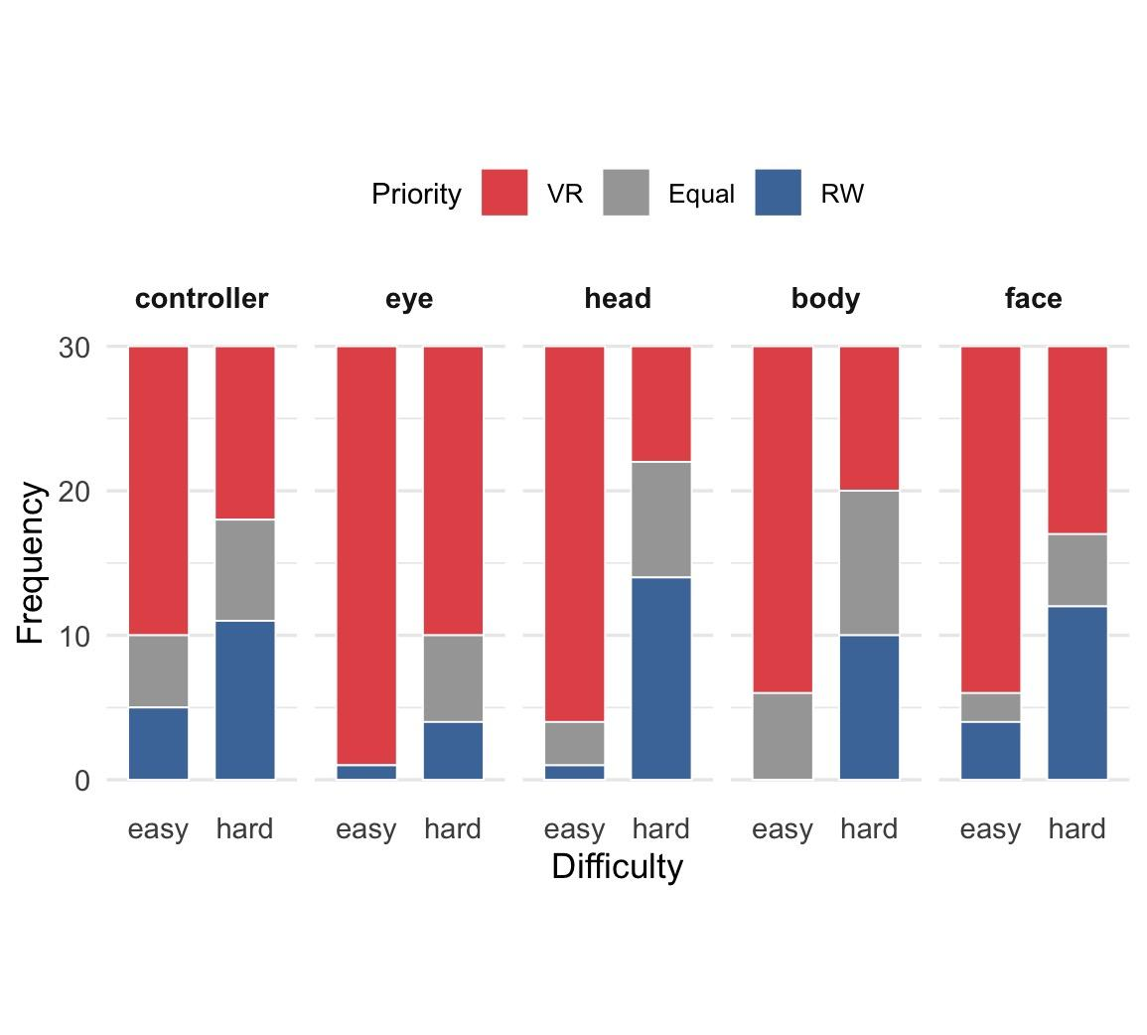
Table X. Summary of the LRT tests on joint effects of mode x difficulty on selected task priority.
 | Mode |  | Difficulty |  | Mode x Difficulty
 | $x_{8}^{2}$ | $p$ | $x_{2}^{2}$ | $p$ | $x_{8}^{2}$ | $p$
$ranking$ | 18.9 | < 0.05 | 56.5 | < 0.001 | 13.2 | 0.11

The results suggested an overall bias toward prioritizing the VR task. They also revealed a pronounced influence of task difficulty, with harder tasks substantially reducing the likelihood of choosing VR over the real-world task. However, differences among hands-free modes were generally small, except for gaze, in which participants showed a stronger tendency to prioritize the VR task.

Interview responses

Reasons for selected task priority
Regarding the overall bias towards prioritizing the VR task, under the easy condition, most participants (n=25) reported that the RW task could be performed “blindly or using peripheral vision”. The RW task was also described as easier that "it didn't require much attention [P13, P20, P23, P25]”. Additionally, some participants prioritized the VR task because “it [VR task] occupied the majority of visual field [P22, P28, P29],” or due to “wearing the headset [P19].” Moreover, controlling the direction of the virtual vehicle was considered more important [P14, P26], with a tendency to avoid collisions [P16]. Under the hard condition, however, the primary reason shifted to greater difficulty of the VR task (n=11), followed by the need to control the direction of the virtual vehicle (n=10) and to avoid collisions (n=10). The greater visual field occupancy of the VR task also remained an important factor [P12, P13, P20, P22].

Participants also reported some modality-specific factors. For example, more participants prioritized the VR task in gaze mode compared with others, primarily because of “the need to continually stare at the gaze buttons (n = 6, easy; n = 13, hard).” Some participants prioritized the RW task in head and body does because “it [the RW task] was easier (n=2, head; n=4, body)” and “the virtual vehicle could be controlled using peripheral vision (n=7, head; n=3, body).” Moreover, three participants prioritized the VR task in face mode because “it was hard to control facial muscle [P1, P25, P26],” whereas two participants prioritized the RW task with strategic abandonment of the VR task due to the high difficulty of blinking one eye alone [P3, P15].

Feedbacks for each modality
Head. Most participants ranked the head mode at the first place, for not interfering with the RW task and allowing performing both tasks simultaneously (n=18). Additionally, they found the head rotation to be accurate, responsive and efficient (n=8), and the most easy in control (n=6), with small degree of movement (n=5). Head rotation was also perceived as intuitive, similar to "steering wheel [P4, P7, P8]” and “motion games [P10].” However, some participants reported feeling dizzy when rotating their heads [P14, P15, P18, P21], and experiencing neck fatigue or pain [P14, P21, P28], such as due to the weight of the MR headset [P17, P19]. Additionally, two participants state head ratotion to be “too responsive to control [P13, P18].” For other drawbacks, few participants reported that the head mode required some learning [P20], hindered the visual field during rotation [P22], tended to cause involuntary body movement [P26], and led to instability in visual field [P27].

Body. Generally, participants agreed that the body mode preserved most of the advantages of the head mode, such as the ability to balance VR and RW tasks (n=12), responsive (n=12) and driving-like control [P30]. Additionally, two participants stated that the body mode “provided high immersion [P18, P26]. However, compared to head rotation, many participants stated that body leaning induced a greater degree of movement (n=6), causing inconvenience [P15, P16], increased fatigue (n=10) and dizziness (n=5). Additionally, participants reported that body lean recucded the sense of space and distance in locating block containers [P1, P9, P18], hindered hand dexterity [P12, P25, P27, P29], caused unstablized and blurred vision for the RW task [P7, P11, P23, P26, P29], and narrowed the visual field for the RW task when leaning backwards [P21].

Face. For the face mode, participants reported that it was responsive (n=13), required only a small degree of movement (n=7), and was convenient to use (n=5), making it ideal for the easy task condition (n=10). However, under hard task condition, participants found it difficult to balance both tasks [P3, P4, P16, P19]. It was commonly agreed that blinking one eye hindered the RW task by reducing the visual field (n=11), and could even lead to panic [P11]. Additionally, around half participant reported difficulty in blinking only one eye (n=13). For example, “It was nearly impossible for me to blink the left eye along [P15].” The issue of accidental activation was also frequently mentioned (n=12). For example, it occurred when looking down at the reality [P5, P7, P11, P16, P18], glancing at the VR scene uisng peripheral vision [P21], blinking unconsciously [P26, P29] or due to eye dryness [P22] and nervousness [P25], as well as opening the mouth and forgot to close it [P14]. Moreover, participants reported taht blinking eyes frequently led to increased eye fatigue (n=8) and blurred vision [P1, P19], and opening mouths led to mouth fatigue [P19, P24]. However, there was some debate regarding whether facial muscle control was natural. Three participants agreed [P8, P19, P27], whereas four participants disagreed [P6, P13, P14, P30].

Gaze. Most feedback received for the gaze mode were nagative. For example, participants reported that their gaze often drifted away from the buttons unconsciously, such as when they were drawn to the roads while turning [P5, P24, P25, P28], attracted by barriers [P25], attracted by blocks [P9], forgetting to dwell for enough duration [P17, P20, P21], or looking around when panic [P14]. Additionally, under hard task condition, around half participants stated the VR and RW tasks interfered with each other, leading to a sense of rushedness (n=13). Meanwhile, most participants method accidental activation, such as when looking down at blocks (n=16), looking around at roads (n=10), and could not resist looking at buttons [P6, P18]. It was also reported that it was difficult to accurately fixate on the buttons [P3, P19, P23, P25], buttons obstructed the VR scene [P6, P18], gaze control was not familiar [P2, P9] and not natural [P18], difficult to use eye for steering, observation and avoiding obstacles simultaneously [P29], as well as unconsciously pausing things in hands when staring at buttons [P1]. Furthermore, staring at buttons cased dizzuniss [P8, P16] and eye fatigue [P11, P14, P22]. For example, one participant stated, “wearing contact lenses…casueing eye dryness and lense sliding issues [P14].” Regarding the advantages of the gaze mode, participants reported it was easier to control under the easy task condition (n=5), ideal for non-busy situations [P4, P14], responsive [P4, P12, P17, P20] and requiring a small degree of movement [P25].

Controller. Similar to gaze, the controller mode received much negative feedback, primarily due to inability to perform both VR and RW task simultaneously (n=14), and causing a sense of rush and time pressure due to frequent task switching (n=17). Additionally, some participants stated it was hard to locate the buttons on the controller [P17, P25] and causing arm fatigue due to frequent lifting the controller [P4]. However, four participants ranked the controller mode as the best because it provided the most precise control [P20, P21, P30], and was the most familiar among all modes [P13]. As for other advantages, participants reported that the controller mode was easy to learn [P21], convenient to use [P24], consistent with the logic of gaming or driving simulation [P7], and had few accidental activations [P23].

Discussion

Pros and Cons of each mode

This suggests that dwelling, or prolonged hovering over a target, was easy to achieve in stable conditions (standing, treadmill) but more challenging in more realistic walking (circuit)(Shin et al., 2025)

not explore issues related to inadvertent activation with dwell triggers, the “Midas touch” (Jacob, 1991) effect in which a target that a user looks at is subsequently automatically, and against their wishes, selected

***the bias toward the VR task in the MR multitasking context, may be due to xxx (from qualitative results)

This was caused by a higher level of frustration due to the delayed processing of voice commands, which led to more overshoots.(Solovjova et al., 2019)

Worse mulittasking perforamcne in VR than RW, (North et al., 2021)

Our results showed that passthrough technology hindered users’ experience in doing everyday tasks. They completed the tasks in longer periods and with higher error rates while using the headset. Additionally, users reported motion sickness and depth misperception, affecting their ability to perform accurate movements (Javadian Farzaneh et al., 2025)

Higer body SSQ than head, HMD, facilitates less granular movement compared to hands (Matviienko et al., 2022)

Continuous voice steering under human walking is usable (Özdel et al., 2025)

body and head:

Torso-steering takes longer and head-steering leads to a higher step count in jogging, Participants found it easier to trigger steps with the head-based method since it does not require full body movement and needs the user to move their head up and down slightly. This could have led to steps being triggered more quickly and easily,.... Head-steering is the most realistic and easiest to use (Hedlund et al., 2023)

The upper-body steering (or leaning) method led to a higher motion sickness than head …As for the steering with upper-body, participants found it very imprecise, had no good feeling for steering and control(Matviienko et al., 2022)

No motion thickness of head yaw in driving…It is likely that the input from vision matched the bodily sensation, considering that the realistic motion was rather high…being in control of the system (Saito et al., 2020)

Comparing other with joysticks:

The results did not support the predictions of the literature that the motion cueing interfaces will provide greater benefits over a non-motion cueing interface such as the Joystick (Kitson et al., 2017)

Joysticsk
higher cybersickness scores in the disorientation subscale overall, and higher scores for joystick input than moton based.(Tregillus et al., 2017),

higher SSQ score when the participants used the gamepad.(Zielasko et al., 2016)

Compare joystick with motion-based (lean) (Harris et al., 2014; Kitson et al., 2015; Kruijff et al., 2016; Marchal et al., 2011; Riecke & Feuereissen, 2012)

controller-based teleportation to be most efficient, accurate and have the highest usability(Prithul et al., 2022)

Limitation
VR and RW tasks, not represent real-world various situations

Different individual has different task priority preferences (Jansen et al., 2016) and strategies

Future work

Abbas, S., & Jeong, H. (2024). Task difficulty impact on multitasking in mixed reality environments. Computers & Education: X Reality, 4, 100065. https://doi.org/10.1016/j.cexr.2024.100065
Al Zayer, M., MacNeilage, P., & Folmer, E. (2020). Virtual Locomotion: A Survey. IEEE Transactions on Visualization and Computer Graphics, 26(6), 2315–2334. https://doi.org/10.1109/TVCG.2018.2887379
Alaee, G., Deasi, A. P., Pena-Castillo, L., Brown, E., & Meruvia-Pastor, O. (2018). A User Study on Augmented Virtuality Using Depth Sensing Cameras for Near-Range Awareness in Immersive VR.
Alonso, R., Bonini, A., Reforgiato Recupero, D., & Spano, L. D. (2022). Exploiting virtual reality and the robot operating system to remote-control a humanoid robot. Multimedia Tools and Applications, 81(11), 15565–15592. https://doi.org/10.1007/s11042-022-12021-z
Anderton, C., Creed, C., Sarcar, S., & Theil, A. (2025). From Teleportation to Climbing: A Review of Locomotion Techniques in the Most Used Commercial Virtual Reality Applications. International Journal of Human–Computer Interaction, 41(4), 1946–1966. https://doi.org/10.1080/10447318.2024.2372151
Aslam, F., & Zhao, R. (2024). Voice-Augmented Virtual Reality Interface for Serious Games. 2024 IEEE Conference on Games (CoG), 1–8. https://doi.org/10.1109/CoG60054.2024.10645616
Auda, J., Gruenefeld, U., Faltaous, S., Mayer, S., & Schneegass, S. (2023). A Scoping Survey on Cross-reality Systems. ACM Comput. Surv., 56(4), 83:1-83:38. https://doi.org/10.1145/3616536
Bahnsen, K. L., Tiemann, L., Plabst, L., & Grundgeiger, T. (2024). Augmented Reality Cues Facilitate Task Resumption after Interruptions in Computer-Based and Physical Tasks. Proceedings of the CHI Conference on Human Factors in Computing Systems, 1–16. https://doi.org/10.1145/3613904.3642666
Balasubramanian, S., Melendez-Calderon, A., & Burdet, E. (2012). A Robust and Sensitive Metric for Quantifying Movement Smoothness. IEEE Transactions on Biomedical Engineering, 59(8), 2126–2136. https://doi.org/10.1109/TBME.2011.2179545
Blanchard, S. J., & Banerji, I. (2016). Evidence-based recommendations for designing free-sorting experiments. Behavior Research Methods, 48(4), 1318–1336. https://doi.org/10.3758/s13428-015-0644-6
Bödding, R., Schriek, S. A., & Maier, G. W. (2025). A systematic review and meta-analysis of mixed reality in vocational education and training: Examining behavioral, cognitive, and affective training outcomes and possible moderators. Virtual Reality, 29(1), 44. https://doi.org/10.1007/s10055-025-01118-z
Bonelli, M. I., & Hamelin, N. (2022). Virtual Reality in Financial Trading and Investing: A Review of Literature and Applications. 2022 8th International Conference on Virtual Reality (ICVR), 97–101. https://doi.org/10.1109/ICVR55215.2022.9848110
Brooks, M., Kristensen, K., Benthem, K. van, Magnusson, A., Berg, C., Nielsen, A., Skaug, H., Mächler, M., & Bolker, B. (2017). glmmTMB Balances Speed and Flexibility Among Packages for Zero-inflated Generalized Linear Mixed Modeling. The R Journal. https://digitalcommons.unl.edu/r-journal/675
Budhiraja, P., Sodhi, R., Jones, B., Karsch, K., Bailey, B., & Forsyth, D. (2015). Where’s My Drink? Enabling Peripheral Real World Interactions While Using HMDs (Version 1). arXiv. https://doi.org/10.48550/ARXIV.1502.04744
Cao, S., Nandakumar, K., Babu, R., & Thompson, B. (2020). Game play in virtual reality driving simulation involving head-mounted display and comparison to desktop display. Virtual Reality, 24(3), 503–513. https://doi.org/10.1007/s10055-019-00412-x
Cardoso, J. C. S. (2016). Comparison of gesture, gamepad, and gaze-based locomotion for VR worlds. Proceedings of the 22nd ACM Conference on Virtual Reality Software and Technology, 319–320. https://doi.org/10.1145/2993369.2996327
Cherni, H., Métayer, N., & Souliman, N. (2020). Literature review of locomotion techniques in virtual reality. International Journal of Virtual Reality, 20(1), 1–20. https://doi.org/10.20870/IJVR.2020.20.1.3183
Cho, H., Chang, E., Yuan, B., Lee, G. A., Piumsomboon, T., & Billinghurst, M. (2025). Bridging Time and Space: A Novel Cross-Reality Interface for Asynchronous Task Guidance. International Journal of Human–Computer Interaction, 1–22. https://doi.org/10.1080/10447318.2025.2499159
Christou, C., Tzanavari, A., Herakleous, K., & Poullis, C. (2016). Navigation in virtual reality: Comparison of gaze-directed and pointing motion control. 2016 18th Mediterranean Electrotechnical Conference (MELECON), 1–6. https://doi.org/10.1109/MELCON.2016.7495413
El Marai, O., Taleb, T., & Song, J. (2023). AR-Based Remote Command and Control Service: Self-Driving Vehicles Use Case. IEEE Network, 37(3), 170–177. https://doi.org/10.1109/MNET.119.2200058
Elkin, L. A., Kay, M., Higgins, J. J., & Wobbrock, J. O. (2021). An Aligned Rank Transform Procedure for Multifactor Contrast Tests. The 34th Annual ACM Symposium on User Interface Software and Technology, 754–768. https://doi.org/10.1145/3472749.3474784
Ghosh, S., Winston, L., Panchal, N., Kimura-Thollander, P., Hotnog, J., Cheong, D., Reyes, G., & Abowd, G. D. (2018). NotifiVR: Exploring Interruptions and Notifications in Virtual Reality. IEEE Transactions on Visualization and Computer Graphics, 24(4), 1447–1456. https://doi.org/10.1109/TVCG.2018.2793698
Griffin, N. N., Liu, J., & Folmer, E. (2018). Evaluation of Handsbusy vs Handsfree Virtual Locomotion. Proceedings of the 2018 Annual Symposium on Computer-Human Interaction in Play, 211–219. https://doi.org/10.1145/3242671.3242707
Grønbæk, J. E. S., Pfeuffer, K., Velloso, E., Astrup, M., Pedersen, M. I. S., Kjær, M., Leiva, G., & Gellersen, H. (2023). Partially Blended Realities: Aligning Dissimilar Spaces for Distributed Mixed Reality Meetings. Proceedings of the 2023 CHI Conference on Human Factors in Computing Systems, 1–16. https://doi.org/10.1145/3544548.3581515
Harris, A., Nguyen, K., Wilson, P. T., Jackoski, M., & Williams, B. (2014). Human joystick: Wii-leaning to translate in large virtual environments. Proceedings of the 13th ACM SIGGRAPH International Conference on Virtual-Reality Continuum and Its Applications in Industry, 231–234. https://doi.org/10.1145/2670473.2670512
Hedlund, M., Lundström, A., Bogdan, C., & Matviienko, A. (2023). Jogging-in-Place: Exploring Body-Steering Methods for Jogging in Virtual Environments. Proceedings of the 22nd International Conference on Mobile and Ubiquitous Multimedia, 377–385. https://doi.org/10.1145/3626705.3627778
Hepperle, D., Weiß, Y., Siess, A., & Wölfel, M. (2019). 2D, 3D or speech? A case study on which user interface is preferable for what kind of object interaction in immersive virtual reality. Computers & Graphics, 82, 321–331. https://doi.org/10.1016/j.cag.2019.06.003
Hilbe, J. M. (2011). Negative Binomial Regression. Cambridge University Press.
Hiroi, Y., Hatada, Y., & Hiraki, T. (2025). Cross-Reality Lifestyle: Integrating Physical and Virtual Lives through Multi-Platform Metaverse (No. arXiv:2504.21337). arXiv. https://doi.org/10.48550/arXiv.2504.21337
Hombeck, J., Voigt, H., Heggemann, T., Datta, R. R., & Lawonn, K. (2023). Tell Me Where To Go: Voice-Controlled Hands-Free Locomotion for Virtual Reality Systems. 2023 IEEE Conference Virtual Reality and 3D User Interfaces (VR), 123–134. https://doi.org/10.1109/VR55154.2023.00028
Hombeck, J., Voigt, H., & Lawonn, K. (2025). Beyond buttons: A user-centric approach to hands-free locomotion in Virtual Reality via voice commands. Computers & Graphics, 132, 104318. https://doi.org/10.1016/j.cag.2025.104318
Hubenschmid, S., Zagermann, J., Butscher, S., & Reiterer, H. (2021). STREAM: Exploring the Combination of Spatially-Aware Tablets with Augmented Reality Head-Mounted Displays for Immersive Analytics. Proceedings of the 2021 CHI Conference on Human Factors in Computing Systems, 1–14. https://doi.org/10.1145/3411764.3445298
Hurt, G. J. (2024). Untethered Displays: The Effects of Mixed Reality on Split-Attention in Fine-Motor Tasks. University of Pittsburgh.
Hyrskykari, A., Istance, H., & Vickers, S. (2012). Gaze gestures or dwell-based interaction? Proceedings of the Symposium on Eye Tracking Research and Applications, 229–232. https://doi.org/10.1145/2168556.2168602
Jacob, R. J. K. (1991). The use of eye movements in human-computer interaction techniques: What you look at is what you get. ACM Transactions on Information Systems, 9(2), 152–169. https://doi.org/10.1145/123078.128728
Jansen, R. J., Egmond, R. van, & Ridder, H. de. (2016). Task Prioritization in Dual-Tasking: Instructions versus Preferences. PLOS ONE, 11(7), e0158511. https://doi.org/10.1371/journal.pone.0158511
Javadian Farzaneh, M., Karadal, P., Aygen, H. B., & Cagiltay, K. (2025). Evaluating Usability Gaps in Passthrough Mixed Reality Interfaces. International Journal of Human–Computer Interaction, 1–17. https://doi.org/10.1080/10447318.2025.2575889
Kanamori, K., Sakata, N., Tominaga, T., Hijikata, Y., Harada, K., & Kiyokawa, K. (2018). Obstacle Avoidance Method in Real Space for Virtual Reality Immersion. 2018 IEEE International Symposium on Mixed and Augmented Reality (ISMAR), 80–89. https://doi.org/10.1109/ISMAR.2018.00033
Kang, H., & Han, J. (2020). SafeXR: Alerting walking persons to obstacles in mobile XR environments. The Visual Computer, 36(10–12), 2065–2077. https://doi.org/10.1007/s00371-020-01907-4
Kennedy, R. S., Lane, N. E., Berbaum, K. S., & Lilienthal, M. G. (1993). Simulator Sickness Questionnaire: An Enhanced Method for Quantifying Simulator Sickness. The International Journal of Aviation Psychology. https://doi.org/10.1207/s15327108ijap0303_3
Kitson, A., Hashemian, A. M., Stepanova, E. R., Kruijff, E., & Riecke, B. E. (2017). Comparing leaning-based motion cueing interfaces for virtual reality locomotion. 2017 IEEE Symposium on 3D User Interfaces (3DUI), 73–82. https://doi.org/10.1109/3DUI.2017.7893320
Kitson, A., Riecke, B. E., Hashemian, A. M., & Neustaedter, C. (2015). NaviChair: Evaluating an Embodied Interface Using a Pointing Task to Navigate Virtual Reality. Proceedings of the 3rd ACM Symposium on Spatial User Interaction, 123–126. https://doi.org/10.1145/2788940.2788956
Klatzky, R. L., Lederman, S. J., & Reed, C. (1987). There’s more to touch than meets the eye: The salience of object attributes for haptics with and without vision. Journal of Experimental Psychology: General, 116(4), 356–369. https://doi.org/10.1037/0096-3445.116.4.356
Kruijff, E., Marquardt, A., Trepkowski, C., Lindeman, R. W., Hinkenjann, A., Maiero, J., & Riecke, B. E. (2016). On Your Feet! Enhancing Vection in Leaning-Based Interfaces through Multisensory Stimuli. Proceedings of the 2016 Symposium on Spatial User Interaction, 149–158. https://doi.org/10.1145/2983310.2985759
Kwak, C., & Clayton-Matthews, A. (2002). Multinomial logistic regression. Nursing Research, 51(6), 404–410. https://doi.org/10.1097/00006199-200211000-00009
Li, J., Reda, A., & Butz, A. (2021). Queasy Rider: How Head Movements Influence Motion Sickness in Passenger Use of Head-Mounted Displays. 13th International Conference on Automotive User Interfaces and Interactive Vehicular Applications, 28–38. https://doi.org/10.1145/3409118.3475137
Lin, C.-C. K., Lee, K.-J., Huang, C.-H., & Sun, Y.-N. (2019). Cerebral control of winking before and after learning: An event-related fMRI study. Brain and Behavior, 9(12), e01483. https://doi.org/10.1002/brb3.1483
Luo, Y., https://orcid.org/0000-0002-6028-2746, View Profile, Wang, J., https://orcid.org/0000-0002-1990-1293, View Profile, Pan, Y., https://orcid.org/0000-0002-6877-3937, View Profile, Luo, S., https://orcid.org/0000-0003-4760-0372, View Profile, Irani, P., https://orcid.org/0000-0002-7716-9280, View Profile, Liang, H.-N., https://orcid.org/0000-0003-3600-8955, & View Profile. (2022). Teleoperation of a Fast Omnidirectional Unmanned Ground Vehicle in the Cyber-Physical World via a VR Interface. In Proceedings of the 18th ACM SIGGRAPH International Conference on Virtual-Reality Continuum and its Applications in Industry (pp. 1–8). https://doi.org/10.1145/3574131.3574432
Lystbæk, M. N., Rosenberg, P., Pfeuffer, K., Grønbæk, J. E., & Gellersen, H. (2022). Gaze-Hand Alignment: Combining Eye Gaze and Mid-Air Pointing for Interacting with Menus in Augmented Reality. Proc. ACM Hum.-Comput. Interact., 6(ETRA), 145:1-145:18. https://doi.org/10.1145/3530886
Ma, X., Yao, Z., Wang, Y., Pei, W., & Chen, H. (2018). Combining Brain-Computer Interface and Eye Tracking for High-Speed Text Entry in Virtual Reality. Proceedings of the 23rd International Conference on Intelligent User Interfaces, 263–267. https://doi.org/10.1145/3172944.3172988
Marchal, M., Pettre, J., & Lecuyer, A. (2011). Joyman: A human-scale joystick for navigating in virtual worlds. 2011 IEEE Symposium on 3D User Interfaces (3DUI), 19–26. https://doi.org/10.1109/3DUI.2011.5759212
Markman, E. M., Cox, B., & Machida, S. (1981). The standard object-sorting task as a measure of conceptual organization. Developmental Psychology, 17(1), 115–117. https://doi.org/10.1037/0012-1649.17.1.115
Martin Elff. (2010). mclogit: Multinomial Logit Models, with or without Random Effects or Overdispersion (p. 0.9.6) [Dataset]. https://doi.org/10.32614/CRAN.package.mclogit
Matviienko, A., Müller, F., Zickler, M., Gasche, L. A., Abels, J., Steinert, T., & Mühlhäuser, M. (2022). Reducing Virtual Reality Sickness for Cyclists in VR Bicycle Simulators. CHI Conference on Human Factors in Computing Systems, 1–14. https://doi.org/10.1145/3491102.3501959
Minakata, K., Hansen, J. P., MacKenzie, I. S., Bækgaard, P., & Rajanna, V. (2019). Pointing by gaze, head, and foot in a head-mounted display. Proceedings of the 11th ACM Symposium on Eye Tracking Research & Applications, 1–9. https://doi.org/10.1145/3317956.3318150
Mine, M. R. (1995). Virtual Environment Interaction Techniques.
Modular Lowpoly Track Roads. (n.d.). [Dataset]. Retrieved July 12, 2025, from https://assetstore.unity.com/packages/3d/environments/roadways/modular-lowpoly-track-roads-free-205188
Monteiro, P., Gonçalves, G., Coelho, H., Melo, M., & Bessa, M. (2021). Hands-free interaction in immersive virtual reality: A systematic review. IEEE Transactions on Visualization and Computer Graphics, 27(5), 2702–2713. https://doi.org/10.1109/TVCG.2021.3067687
Monteiro, P., Gonçalves, G., Peixoto, B., Melo, M., & Bessa, M. (2023). Evaluation of Hands-Free VR Interaction Methods During a Fitts’ Task: Efficiency and Effectiveness. IEEE Access, 11, 70898–70911. https://doi.org/10.1109/ACCESS.2023.3293057
Narbayev, B. (2025). Exploring controller-free teleportation techniques for efficient virtual reality navigation [University of British Columbia]. https://doi.org/10.14288/1.0449818
Nayak, M., Kangas, J., & Raisamo, R. (2025). A Study of NLP-Based Speech Interfaces in Medical Virtual Reality. Multimodal Technologies and Interaction, 9(6), 50. https://doi.org/10.3390/mti9060050
North, S., North, M., Garofalo, D., & Parajapati, D. (2021). The effects of mixed reality immersion on users’ performance and perception of multitasking while performing concurrent real world tasks. J. Comput. Sci. Coll., 36(8), 73–88.
Osking, H., & Doucette, J. A. (2019). Enhancing Emotional Effectiveness of Virtual-Reality Experiences with Voice Control Interfaces. In D. Beck, A. Peña-Rios, T. Ogle, D. Economou, M. Mentzelopoulos, L. Morgado, C. Eckhardt, J. Pirker, R. Koitz-Hristov, J. Richter, C. Gütl, & M. Gardner (Eds.), Immersive Learning Research Network (Vol. 1044, pp. 199–209). Springer International Publishing. https://doi.org/10.1007/978-3-030-23089-0_15
Özdel, S., Buldu, K. B., Kasneci, E., & Bozkir, E. (2025). Exploring Context-aware and LLM-driven Locomotion for Immersive Virtual Reality (No. arXiv:2504.17331). arXiv. https://doi.org/10.48550/arXiv.2504.17331
Pfeuffer, K., Mayer, B., Mardanbegi, D., & Gellersen, H. (2017). Gaze + pinch interaction in virtual reality. Proceedings of the 5th Symposium on Spatial User Interaction, 99–108. https://doi.org/10.1145/3131277.3132180
Prithul, A., Bhandari, J., Spurgeon, W., & Folmer, E. (2022). Evaluation of Hands-free Teleportation in VR. Proceedings of the 2022 ACM Symposium on Spatial User Interaction, 1–6. https://doi.org/10.1145/3565970.3567683
Qiu, L., Kim, E. S., Suh, S., Sidenmark, L., & Grossman, T. (2025). MaRginalia: Enabling In-person Lecture Capturing and Note-taking Through Mixed Reality. Proceedings of the 2025 CHI Conference on Human Factors in Computing Systems, 1–15. https://doi.org/10.1145/3706598.3714065
Rebsdorf, M. R., Khumsan, T., Valvik, J., Nilsson, N. C., & Adjorlu, A. (2023). Blink Don’t Wink: Exploring Blinks as Input for VR Games. Proceedings of the 2023 ACM Symposium on Spatial User Interaction, 1–8. https://doi.org/10.1145/3607822.3614527
Riecke, B. E., & Feuereissen, D. (2012). To move or not to move: Can active control and user-driven motion cueing enhance self-motion perception (“vection”) in virtual reality? Proceedings of the ACM Symposium on Applied Perception, 17–24. https://doi.org/10.1145/2338676.2338680
Rolff, T., Gabel, J., Zerbin, L., Hypki, N., Schmidt, S., Lappe, M., & Steinicke, F. (2025). A Hands-free Spatial Selection and Interaction Technique using Gaze and Blink Input with Blink Prediction for Extended Reality (No. arXiv:2501.11540). arXiv. https://doi.org/10.48550/arXiv.2501.11540
Saito, Y., Kawashima, K., & Hirakawa, M. (2020). Effectiveness of a Head Movement Interface for Steering a Vehicle in a Virtual Reality Driving Simulation. Symmetry, 12(10), Article 10. https://doi.org/10.3390/sym12101645
Salvucci, D. D., Taatgen, N. A., & Borst, J. P. (2009). Toward a unified theory of the multitasking continuum: From concurrent performance to task switching, interruption, and resumption. Proceedings of the SIGCHI Conference on Human Factors in Computing Systems, 1819–1828. https://doi.org/10.1145/1518701.1518981
Schneider, D., Otte, A., Gesslein, T., Gagel, P., Kuth, B., Damlakhi, M. S., Dietz, O., Ofek, E., Pahud, M., Kristensson, P. O., Muller, J., & Grubert, J. (2019). ReconViguRation: Reconfiguring Physical Keyboards in Virtual Reality. IEEE Transactions on Visualization and Computer Graphics, 25(11), 3190–3201. https://doi.org/10.1109/TVCG.2019.2932239
Shin, Y., Esteves, A., & Oakley, I. (2025). Using Augmented Reality on the go: Understanding the effects of mobility on user performance and subjective workload across eye, head, and hand ray pointing. International Journal of Human-Computer Studies, 204, 103597. https://doi.org/10.1016/j.ijhcs.2025.103597
Sidenmark, L., & Gellersen, H. (2019). Eye&Head: Synergetic Eye and Head Movement for Gaze Pointing and Selection. Proceedings of the 32nd Annual ACM Symposium on User Interface Software and Technology, 1161–1174. https://doi.org/10.1145/3332165.3347921
Sidenmark, L., Mardanbegi, D., Gomez, A. R., Clarke, C., & Gellersen, H. (2020). BimodalGaze: Seamlessly Refined Pointing with Gaze and Filtered Gestural Head Movement. ACM Symposium on Eye Tracking Research and Applications, 1–9. https://doi.org/10.1145/3379155.3391312
Solovjova, A., Hatscher, B., & Hansen, C. (2019). Influence of augmented reality interaction on a primary task for the medical domain. 10.18420/muc2019. https://dl.gi.de/handle/20.500.12116/25152
Sun, Y., & Schöning, J. (2025). Experiencing the World through Imperfect Lenses: An Autoethnography of Living in Mixed Reality. Proceedings of the 2025 ACM Designing Interactive Systems Conference, 1628–1643. https://doi.org/10.1145/3715336.3735841
Terziman, L., Marchal, M., Emily, M., Multon, F., Arnaldi, B., & Lécuyer, A. (2010). Shake-your-head: Revisiting walking-in-place for desktop virtual reality. Proceedings of the 17th ACM Symposium on Virtual Reality Software and Technology, 27–34. https://doi.org/10.1145/1889863.1889867
Tregillus, S., Al Zayer, M., & Folmer, E. (2017). Handsfree Omnidirectional VR Navigation using Head Tilt. Proceedings of the 2017 CHI Conference on Human Factors in Computing Systems, 4063–4068. https://doi.org/10.1145/3025453.3025521
Verkennis, B., Weelden, E. van, Marogna, F. L., Alimardani, M., Wiltshire, T. J., & Louwerse, M. M. (2025). Predicting Workload in Virtual Flight Simulations using EEG Features (Including Post-hoc Analysis in Appendix). 82–89. https://doi.org/10.1109/AIxVR63409.2025.00019
Vlahovic, S., Skorin-Kapov, L., Suznjevic, M., & Pavlin-Bernardic, N. (2024). Not just cybersickness: Short-term effects of popular VR game mechanics on physical discomfort and reaction time. Virtual Reality, 28(2), 108. https://doi.org/10.1007/s10055-024-01007-x
VlahovicSara, SlivarIvan, SilicMatko, Skorin-kapovLea, & SuznjevicMirko. (2024). Exploring the Facets of the Multiplayer VR Gaming Experience. ACM Transactions on Multimedia Computing, Communications and Applications. https://doi.org/10.1145/3649897
Von Willich, J., Funk, M., Müller, F., Marky, K., Riemann, J., & Mühlhäuser, M. (2019). You Invaded my Tracking Space! Using Augmented Virtuality for Spotting Passersby in Room-Scale Virtual Reality. Proceedings of the 2019 on Designing Interactive Systems Conference, 487–496. https://doi.org/10.1145/3322276.3322334
Wang, K.-J., Liu, Q., Zhao, Y., Zheng, C. Y., Vhasure, S., Liu, Q., Thakur, P., Sun, M., & Mao, Z.-H. (2018). Intelligent Wearable Virtual Reality (VR) Gaming Controller for People with Motor Disabilities. 2018 IEEE International Conference on Artificial Intelligence and Virtual Reality (AIVR), 161–164. https://doi.org/10.1109/AIVR.2018.00034
Wang, K.-J., You, K., Chen, F., Thakur, P., Urich, M., Vhasure, S., & Mao, Z.-H. (2018). Development of Seamless Telepresence Robot Control Methods to Interact with the Environment Using Physiological Signals. Companion of the 2018 ACM/IEEE International Conference on Human-Robot Interaction, 44. https://doi.org/10.1145/3173386.3177843
Wang, W., Song, F., & Zhu, T. (2022). SAME: The Design Space for Seamless Automotive Multimodal Experience. IT Professional, 24(3), 35–42. IT Professional. https://doi.org/10.1109/MITP.2022.3172943
Wickens, C. D. (2002). Multiple resources and performance prediction. Theoretical Issues in Ergonomics Science, 3(2), 159–177. https://doi.org/10.1080/14639220210123806
Widiyanti, D. E., Asmoro, K., & Shin, S. Y. (2024). HoloGCS: Mixed reality-based ground control station for unmanned aerial vehicle. Virtual Reality, 28(1), 40. https://doi.org/10.1007/s10055-023-00914-9
Wobbrock, J. O., Findlater, L., Gergle, D., & Higgins, J. J. (2011). The aligned rank transform for nonparametric factorial analyses using only anova procedures. Proceedings of the SIGCHI Conference on Human Factors in Computing Systems, 143–146. https://doi.org/10.1145/1978942.1978963
Zhang, P., & Riggs, S. L. (2025). Multitasking Between Realities: An Examination of Multitasking Using Augmented Reality Under Different Task Demand Levels. Proceedings of the Human Factors and Ergonomics Society Annual Meeting, 10711813251357901. https://doi.org/10.1177/10711813251357901
Zhang, Y., Orthmann, B., Welle, M. C., Van Haastregt, J., & Kragic, D. (2025). LLM-Driven Augmented Reality Puppeteer: Controller-Free Voice-Commanded Robot Teleoperation. In A. Coman & S. Vasilache (Eds.), Social Computing and Social Media (pp. 97–112). Springer Nature Switzerland. https://doi.org/10.1007/978-3-031-93539-8_7
Zhao, S., Tan, F., & Fennedy, K. (2023). Heads-Up Computing Moving Beyond the Device-Centered Paradigm. Commun. ACM, 66(9), 56–63. https://doi.org/10.1145/3571722
Zielasko, D., Horn, S., Freitag, S., Weyers, B., & Kuhlen, T. W. (2016). Evaluation of hands-free HMD-based navigation techniques for immersive data analysis. 2016 IEEE Symposium on 3D User Interfaces (3DUI), 113–119. https://doi.org/10.1109/3DUI.2016.7460040

